

FLUFFY CHARACTER BASED INFORMATION TRUSTWORTHINESS REVIEWING FOR DEPENDABLE CLOUD CAPACITY FRAMEWORKS

A PROJECT REPORT

Submitted by

ASHWIN KUMAR.D [REGISTER NO:211417104027]
DHESH KUMAAR A [REGISTER NO:211417104052]
BALAJI.R [REGISTER NO:211417104029]

in partial fulfillment for the award of the degree of

BACHELOR OF ENGINEERING

IN

COMPUTER SCIENCE AND ENGINEERING

PANIMALAR ENGINEERING COLLEGE, CHENNAI-600123.

ANNA UNIVERSITY: CHENNAI 600 025

APRIL 2021

BONAFIDE CERTIFICATE

Certified that this project report “FLUFFY CHARACTER BASED INFORMATION TRUSTWORTHINESS REVIEWING FOR DEPENDABLE CLOUD CAPACITY FRAMEWORKS” is the bonafide work of “ASHWIN KUMAR.D (2017PECCS366), BALAJI.R (2017PECCS369), DHESH KUMAAR A (2017PECCS382)” who carried out the project work under my supervision.

SIGNATURE SIGNATURE

Dr.S. MURUGAVALLI, M.E., Ph.D., Mr. N. SATHISH, M.E.,
HEAD OF THE DEPARTMENT ASSISTANT PROFESSOR, DEPARTMENT OF CSE, DEPARTMENT OF CSE,
PANIMALAR ENGINEERING COLLEGE, PANIMALAR ENGINEERING COLLEGE, NAZARATHPETTAI, NAZARATHPETTAI,
POONAMALLEE, POONAMALLEE,
CHENNAI-600 123. CHENNAI-600 123.

Certified that the above candidate(s) was/ were examined in the Anna University Project Viva-Voce Examination held on ………….

INTERNAL EXAMINER EXTERNAL EXAMINER

ACKNOWLEDGEMENT

We express our deep gratitude to our respected Secretary and Correspondent Dr.P.CHINNADURAI, M.A., Ph.D. for his kind words and enthusiastic motivation, which inspired us a lot in completing this project.

We would like to extend our heartfelt and sincere thanks to our Directors
Tmt. C. VIJAYARAJESWARI, Thiru. Dr.C. SAKTHIKUMAR, M.E., Ph.D., and
Tmt. SARANYASREE SAKTHIKUMAR B.E., M.B.A., for providing us with the necessary facilities for completion of this project.

We also express our gratitude to our Principal Dr. K. Mani, M.E., Ph.D. for his timely concern and encouragement provided to us throughout the course.

We thank the HOD of CSE Department, Dr. S. MURUGAVALLI, M.E., Ph.D.,
for the support extended throughout the project.

We would like to thank my Project Guide Mr. N. Sathish, M.E., and all the faculty members of the Department of CSE for their advice and suggestions for the successful completion of the project.
ASHWIN KUMAR.D,
DHESH KUMAAR A,
BALAJI.R

ABSTRACT

Information uprightness, a center security issue in solid distributed storage, has gotten a lot of consideration. Information inspecting conventions empower a verifier to productively check the respectability of the re-appropriated information without downloading the information. A key research challenge related with existing structures of information evaluating conventions is the multifaceted nature in key administration. We try to address the mind-boggling key the board challenge in cloud information honesty checking by presenting fluffy character-based reviewing, the first in such a methodology, to the best of our insight.
All the more explicitly, we present the crude of fluffy personality - based information inspecting, where a client's character can be seen as a lot of illustrative traits. We formalize the framework model and the security model for this new crude. We at that point present a solid development of fluffy personality based inspecting convention by using biometrics as the fluffy character. The new convention offers the property of blunder resilience, in particular, it ties with private key to one character which can be utilized to check the rightness of a reaction created with another character, if and just if the two personalities are adequately close. At long last, we build up a model usage of the convention which shows the common sense of the proposition.

LIST OF FIGURES

CHAPTER NO. | TITLE | PAGE NO.
4. | SYSTEM DESIGN
 | 4.1. ER-Diagram | 22
 | 4.2. Data Flow Diagram of User | 26
 | 4.3. Data Flow Diagram of TPA | 27
 | 4.4. Data Flow Diagram of Cloud Server | 27
 | 4.5. Use Case Diagram | 32
 | 4.6. Class Diagram | 32
 | 4.7. Sequence Diagram | 33
 | 4.8. Activity Diagram | 33
5. | SYSTEM ARCHITECTURE
 | 5.1. System Architecture | 35

LIST OF TABLES

CHAPTER NO. | TITLE | PAGE NO.
3. | SYSTEM ANALYSIS
 | 3.1. Hardware Requirements | 13
 | 3.2. Software Requirements | 13
4. | SYSTEM DESIGN
 | 4.1. Data Dictionary of User | 23
 | 4.2. Data Dictionary of File Upload | 23
 | 4.3. Data Dictionary of Cloud Request | 24
 | 4.4. Data Dictionary of Audit Request | 25
6. | SYSTEM TESTING
 | 6.1. Test Case for User Module | 40
 | 6.2. Test Case for KGC Module | 41
 | 6.3. Test Case for Cloud Server Module | 41

TABLE OF CONTENTS

CHAPTER NO. | TITLE | PAGE NO.
 | ABSTRACT | iv
 | LIST OF FIGURES | v
 | LIST OF TABLES | vi
1. | INTRODUCTION | 1
 | 1.1 Overview | 2
2. | LITERATURE SURVEY | 4
3. | SYSTEM ANALYSIS | 9
 | 3.1 Existing System | 10
 | 3.2 Proposed system | 10
 | 3.3 Requirement Analysis and Specification | 11
 | 3.3.1 Input Requirements | 11
 | 3.3.2 Output Requirements | 12
 | 3.4 Feasibility Study | 12
 | 3.4.1 Technical Feasibility | 12
 | 3.4.2 Economic Feasibility | 13
 | 3.5 Hardware Requirements | 13
 | 3.6 Software Requirements | 13
 | 3.7 Software Specification | 14

CHAPTER NO. | TITLE | PAGE NO.
4. | SYSTEM DESIGN | 21
 | 4.1. ER diagram | 22
 | 4.2 Data dictionary | 22
 | 4.3 Data Flow Diagram | 25
 | 4.4 UML Diagrams | 28
5. | ARCHITECTURE | 34
 | 5.1 Architecture Overview | 35
 | 5.2 System Module | 35
 | 5.2.1 Modules Explanation | 36
6. | TESTING | 37
 | 6.1 System Testing | 38
 | 6.2 Unit Testing | 39
 | 6.3 Test Cases | 40
7. | CONCLUSION | 42
 | 7.1 Conclusion | 43
 | APPENDICES
 | A.1 Sample Screens | 44
 | A.2 Sample Code | 48
 | REFERENCES | 83

CHAPTER 1 INTRODUCTION

1.1 OVERVIEW

As a basic service of IaaS (Infrastructure as a service) model in cloud computing, cloud storage enables data owners to store their files to the cloud and deletes the local copy of the data, which dramatically reduces the burden of maintenance and management of the data. Cloud storage has a number of eye-catching features, say global data access, independent geographical locations, on demand self- service, resource elasticity and so on. Currently, both the individuals and big companies are enjoying the benefits due to cloud storage services. Despite the benefits offered by cloud storage, there are many inherent security risks.

For example, when data owners outsource their data to the cloud, they generally lose physical possession of their data and may have no idea where their data are actually stored or who has the permission to getting access to their data. That is to say, it is the cloud servers who control the fate of the data after the data owners uploading their files to the cloud. While most cloud service providers are honest (e.g., due to their vested interest in ensuring a good reputation and avoiding civil litigations), data loss incidents are inevitable. As a consequence, data owners require a strong integrity guarantee of their outsourced data and they want to make sure that the cloud servers store their data correctly.

Cloud data integrity is of particular importance in secure and reliable cloud storage. To solve the aforementioned problems, RDIC, is also known as data integrity auditing, which comprises three parties, namely: cloud server, data owner and third-party auditor (TPA). A publicly verifiable RDIC protocol allows the TPA or anyone to check the integrity of the stored data on the cloud without the need to retrieve the entire dataset.

Firstly, generation, management and revocation of certificates is complex and computationally expensive, and consequently scalability is challenging. Secondly, the level of trust required of CA may be unrealistic, particularly in light of recent high-profile incidents. biometric-based schemes authenticate or identify a user based on one’s physiological or behavioral features and deployed in a number of real-world applications.

This is unsurprising, due to the benefits offered by biometric-based schemes. For example, biometric-based identities are easily portable and cannot be forgotten or misplaced. But in biometric based schemes, the data owner needs to submit his/her identity to the Key Generating Center in order to receive the encryption key which may lead to a security problem as the KGC knows both the biometric identity and the encryption key which can then be used by attackers to access user’s cloud data. So, we decided to eliminate this problem by introducing the concept of token, the idea is that the data owner submits his/her biometric identity to the TPA and then the TPA returns a unique token to the user based on his/her biometric.

The data owner then submits cloud data. So, we decided to eliminate this problem by introducing the concept of token, the idea is that the data owner submits his/her biometric identity to the TPA and then the TPA returns a unique token to the user based on his/her biometric.

The data owner then submits his/her unique token to the KGC in order to receive the encryption key and thus the KGC doesn’t know the biometric identity of the data owner, all that it knows is the unique token and the encryption key not the user’s biometric identity, so the attacker can never know which user uses which unique token.

CHAPTER 2 LITERATURE SURVEY
NIST Cloud Computing Standards Roadmap

AUTHORS: M. Hogan, F. Liu, A. Sokol and J. Tong

NIST has been designated by the Federal Chief Information Officer (CIO) to accelerate the federal government’s secure adoption of cloud computing by leading efforts to develop standards and guidelines in close consultation and collaboration with standards bodies, the private sector, and other stakeholders. Standards are critical to ensure cost-effective and easy migration, to ensure that mission-critical requirements can be met, and to reduce the risk that sizable investments may become prematurely technologically obsolete. Standards are key elements required to ensure a level playing field in the global marketplace. The NIST Cloud Computing Standards Roadmap Working Group has surveyed the existing standards landscape for interoperability, performance, portability, security, and accessibility standards/models/studies/use cases/conformity assessment programs, etc., relevant to cloud computing. Using this available information, current standards, standards gaps, and standardization priorities are identified within this document.

Provable data possession at untrusted stores

AUTHORS: G. Ateniese, R. C. Burns, R. Curtmola, J. Herring, L. Kissner, Z. N.
J. Peterson and D. X. Song

We introduce a model for provable data possession (PDP) that allows a client that has stored data at an untrusted server to verify that the server possesses the original data without retrieving it. The model generates probabilistic proofs of possession by sampling random sets of blocks from the server, which drastically reduces I/O costs. The client maintains a constant amount of metadata to verify the proof. The challenge/response protocol transmits a small, constant amount of data, which minimizes network communication. Thus, the PDP model for remote data checking supports large data sets in widely-distributed storage system.

We present two provably-secure PDP schemes that are more efficient than previous solutions, even when compared with schemes that achieve weaker guarantees. In particular, the overhead at the server is low (or even constant), as opposed to linear in the size of the data. Experiments using our implementation verify the practicality of PDP and reveal that the performance of PDP is bounded by disk I/O and not by cryptographic computation.

Proofs of storage from homomorphic identification protocols

AUTHORS: G. Ateniese, S. Kamara and J. Katz

Proofs of storage (PoS) are interactive protocols allowing a client to verify that a server faithfully stores a file. Previous work has shown that proofs of storage can be constructed from any homomorphic linear authenticator (HLA). The latter, roughly speaking, are signature/message authentication schemes where ‘tags’ on multiple messages can be homomorphically combined to yield a ‘tag’ on any linear combination of these messages.

We provide a framework for building public-key HLAs from any identification protocol satisfying certain homomorphic properties. We then show how to turn any public-key HLA into a publicly-verifiable PoS with communication complexity independent of the file length and supporting an unbounded number of verifications. We illustrate the use of our transformations by applying them to a variant of an identification protocol by Shoup, thus obtaining the first unbounded-use PoS based on factoring (in the random oracle model).

A method for obtaining digital signatures and public-key cryptosystem

AUTHORS: R. L. Rivest, A. Shamir and L. Adleman

An encryption method is presented with the novel property that publicly revealing an encryption key does not thereby reveal the corresponding decryption key. This has two important consequences: (1) Couriers or other secure means are not needed to transmit keys, since a message can be enciphered using an encryption key publicly revealed by the intented recipient. Only he can decipher the message, since only he knows the corresponding decryption key. (2) A message can be “signed” using a privately held decryption key. Anyone can verify this signature using the corresponding publicly revealed encryption key. Signatures cannot be forged, and a signer cannot later deny the validity of his signature. This has obvious applications in “electronic mail” and “electronic funds transfer” systems. A message is encrypted by representing it as a number M, raising M to a publicly specified power e, and then taking the remainder when the result is divided by the publicly specified product, n, of two large secret primer numbers p and q. Decryption is similar; only a different, secret, power d is used, where e * d ≡ 1(mod (p - 1) * (q - 1)). The security of the system rests in part on the difficulty of factoring the published divisor, n.

Compact proofs of retrievability

AUTHORS: H. Shacham and B.Waters
In a proof-of-retrievability system, a data storage center convinces a verifier that he is actually storing all of a client’s data. The central challenge is to build systems that are both efficient and provably secure – that is, it should be possible to extract the client’s data from any prover that passes a verification check. In this paper, we give the first proof-of-retrievability schemes with full proofs of security against arbitrary adversaries in the strongest model, that of Juels and Kaliski. Our first scheme, built from BLS signatures and secure in the random oracle model, has the shortest query and response of any proof-of-retrievability with public verifiability. Our second scheme, which builds elegantly on pseudorandom functions (PRFs) and is secure in the standard model, has the shortest response of any proof-of-retrievability scheme with private verifiability (but a longer query). Both schemes rely on homomorphic properties to aggregate a proof into one small authenticator value.

CHAPTER 3 SYSTEM ANALYSIS

EXISTING SYSTEM

When data owners outsource their data to the cloud, they generally lose physical possession of their data and may have no idea where their data are actually stored or who has the permission to getting access to their data. As a consequence, data owners require a strong integrity guarantee of their outsourced data and they want to make sure that the cloud servers store their data correctly. To solve the aforementioned problems a number of ID-based schemes (including remote data auditing protocols) have been proposed for example, several ID-based remote data auditing protocols were proposed and, in these protocols, identity information is an arbitrary text string. There are a number of limitations inherent in such systems. For example, the user’s identity may not be truly unique if the identity information is not chosen properly Secondly, a user needs to “prove” to the private key generator Centre that he is indeed entitled to a claimed identity, such as presenting a legal document supporting the claim. However, the supporting documents are subject to forgery. Generally, both ID-based and PKI-based schemes rely on what you know (e.g., identity information) and what you have (e.g., digital certificate and password).

PROPOSED SYSTEM

In the existing system, the KGC is designed in such a way that it receives the biometric identity in order to provide the encryption key which may lead to security problem as the KGC knows both the biometric identity and encryption key of the person which can then be used by some attackers to have access to the cloud data. So, we overcome this issue by designing the KGC in such a way that it receives the unique token from the data owner (token is provided to the user based on biometric identity by the TPA) and provides an encryption key corresponding to the unique token to the data owner. As a result, the TPA only knows the biometric identity not the encryption key and the KGC only knows the unique token not the biometric identity. The cloud server is used only to save the encrypted blocks of data.
ADVANTAGES:
- We seek to address the complex key management challenge in cloud data integrity checking by introducing fuzzy identity-based auditing
- Biometric-based identities are easily portable and cannot be forgotten or misplaced

REQUIREMENT ANALYSIS AND SPECIFICAITON

The requirement engineering process of feasibility study, requirements elicitation and analysis, requirement specification, requirements validation and requirement management. Requirement elicitation and analysis is an iterative process that can
be represented as a spiral of activities, namely requirements discovery requirements classification and organization, requirement negotiation and requirements documentation.

INPUT REQUIREMENT

The input design is the link between the information system and the user. It comprises the developing specification and procedures for data preparation and those steps are necessary to put transaction data in to a usable form for processing can be achieved by inspecting the computer to read data from a written or printed document or it can occur by having people keying the data directly into the system. The design of input focuses on controlling the amount of input required, controlling the errors, avoiding delay, avoiding extra steps and keeping the process simple. The input is designed in such a way so that it provides security and ease of use with retaining the privacy.

OUTPUT REQUIREMENT

A quality output is one, which meets the requirements of the end user and presents the information clearly. In any system results of processing are communicated to the users and to other system through outputs. In output design it is determined how the information is to be displaced for immediate need and also the hard copy output. It is the most important and direct source information to the user. Efficient and intelligent output design improves the system’s relationship to help user decision-making.

FEASIBILITY STUDY
A feasibility study is carried out to select the best system that meets performance requirements. The main aim of the feasibility study activity is to determine that it would be financially and technically feasible to develop the product.

TECHNICAL FEASIBILITY
This is concerned with specifying the software will successfully satisfy the user requirement. Open source and business-friendly and it is truly cross platform, easily deployed and highly extensible.

ECONOMIC FEASIBILITY
Economic analysis is the most frequently used technique for evaluating the effectiveness of a proposed system. The enhancement of the existing system doesn’t incur any kind of increase in the expenses. Programming Language for Web-App development is open source and readily available for all users. Since, the project is runned in the NetBeans and Apache Tomcat, hence it is cost efficient.

HARDWARE REQUIREMENTS

Processor | Pentium IV 2.4 GHz
Hard disk | 40 GB
RAM | 512 MB
Monitor | 14/15 inches Color

  - SOFTWARE REQUIEMENTS

Development Environment | NetBeans IDE
Front End Language | Html, CSS, JavaScript
Back-End Language | JAVA/J2EE
Database | MYSQL
Server | Apache Tomcat

  - SOFTWARE SPECIFICATION

HTML

Hypertext Markup Language (HTML) is the standard markup language for documents designed to be displayed in a web browser. It can be assisted by technologies such as Cascading Style Sheets (CSS) and scripting languages such as JavaScript.
Web browsers receive HTML documents from a web server or from local storage and render the documents into multimedia web pages. HTML describes the structure of a web page semantically and originally included cues for the appearance of the document.
HTML elements are the building blocks of HTML pages. With HTML constructs, images and other objects such as interactive forms may be embedded into the rendered page. HTML provides a means to create structured documents by denoting structural semantics for text such as headings, paragraphs, lists, links, quotes and other items. HTML elements are delineated by tags, written using angle brackets. Tags such as <img /> and <input /> directly introduce content into the page. Other tags such as <p> surround and provide information about document
text and may include other tags as sub-elements. Browsers do not display the HTML tags, but use them to interpret the content of the page.
HTML can embed programs written in a scripting language such as JavaScript, which affects the behavior and content of web pages. Inclusion of CSS defines the look and layout of content. The World Wide Web Consortium (W3C), former maintainer of the HTML and current maintainer of the CSS standards, has encouraged the use of CSS over explicit presentational HTML since 1997.
HTML markup consists of several key components, including those called tags (and their attributes), character-based data types, character references and entity references. HTML tags most commonly come in pairs like
<h1> and </h1>, although some represent empty elements and so are unpaired, for example <img>. The first tag in such a pair is the start tag, and the second is the end tag (they are also called opening tags and closing tags).
HTML documents imply a structure of nested HTML elements. These are indicated in the document by HTML tags, enclosed in angle brackets thus:
In the simple, general case, the extent of an element is indicated by a pair of tags: a "start tag" <p> and "end tag"</p>. The text content of the element, if any, is placed between these tags.

CSS

      - INTRODUCTION
Cascading Style Sheets (CSS) is a style sheet language used for describing the presentation of a document written in a markup language like HTML. CSS is a cornerstone technology of the World Wide Web, alongside HTML and JavaScript. CSS is designed to enable the separation of presentation and content, including layout, colors, and fonts. This separation can improve content accessibility, provide more flexibility and control in the specification of presentation characteristics, enable multiple web pages to share formatting by specifying the relevant CSS in a separate .css file, and reduce complexity and repetition in the structural content.
Separation of formatting and content also makes it possible to present the same markup page in different styles for different rendering methods, such as on-screen, in print, by voice (via speech-based browser or screen reader), and on Braille- based tactile devices. CSS also has rules for alternate formatting if the content is accessed on a mobile device.
The name cascading comes from the specified priority scheme to determine which style rule applies if more than one rule matches a particular element. This cascading priority scheme is predictable.
The CSS specifications are maintained by the World Wide Web Consortium (W3C). Internet media type (MIME type) text/css is registered for use with CSS by RFC 2318 (March 1998). The W3C operates a free CSS validation service for CSS documents. In addition to HTML, other markup languages support the use of CSS including XHTML, plain XML, SVG, and XUL.

USE OF CSS
Before CSS, nearly all presentational attributes of HTML documents were contained within the HTML markup. All font colors, background styles, element alignments, borders and sizes had to be explicitly described, often repeatedly, within the HTML. CSS let's authors move much of that information to another file, the style sheet, resulting in considerably simpler HTML.
For example, headings (h1 elements), sub-headings (h2), sub-sub-headings (h3), etc., are defined structurally using HTML. In print and on the screen, the choice of font, size, color and emphasis for these elements is presentational.
Before CSS, document authors who wanted to assign such typographic characteristics to, say, all h2 headings had to repeat HTML presentational markup for each occurrence of that heading type. This made documents more complex, larger, and more error-prone and difficult to maintain. CSS allows the separation of presentation from structure. CSS can define color, font, text alignment, size, borders, spacing, layout and many other typographic Characteristics, and can do so independently for on-screen and printed views. CSS also defines non-visual styles, such as reading speed and emphasis for aural text readers.

MySQL

MySQL is an opensource RDBMS. A relational database organizes data into one or more data tables in which data types may be related to each other; these relations help structure the data. SQL is a language-programmers use to create, modify and extract data from the relational database, as well as control user access to the database. In addition to relational databases and SQL, an RDBMS like MySQL works with an OS to implement a relational database in a computer's storage system, manages users, allows for network access and facilitates testing database integrity and creation of backups.
MySQL is free and open source under the terms of the GNU, and is also available under a variety of proprietary licenses. MySQL was owned and sponsored by the Swedish company MySQL AB, which was bought Oracle. In 2010, when Oracle acquired Sun, Widenius forked the opensource MySQL project to create MariaDB.
MySQL has stand-alone clients that allow users to interact directly with a MySQL database using SQL, but more often MySQL is used with other programs to implement applications that need relational database capability.

APACHE TOMCAT SERVER

Tomcat is a Java servlet container and web server from the Jakarta project of the Apache Software Foundation (http://jakarta.apache.org). A web server is, of course, the program that dishes out web pages in response to requests from a user sitting at a web browser. But web servers aren’t limited to serving up static HTML pages; they can also run programs in response to user requests and return the dynamic results to the user’s browser. This is an aspect of the web that Apache’s Tomcat is very good at because Tomcat provides both Java servlet and Java Server Pages (JSP) technologies (in addition to traditional static pages and external CGI programming). The result is that Tomcat is a good choice for use as a web server for many applications. And it’s a very good choice if you want a free, open source (http://opensource.org/) servlet and JSP engine. Tomcat can be used stand-alone, but it is often used ―behind‖ traditional web servers such as Apache http, with the traditional server serving static pages and Tomcat serving dynamic
Servlet and JSP requests. No matter what we call Tomcat, a Java servlet container or servlet and JSP engine, we mean Tomcat provides an environment in which servlets can run and JSP can be processed. Similarly, we can absolutely say a CGI- enabled Web server is a CGI program container or engine since the server can accommodate CGI programs and communicate with them according to CGI specification. Between Tomcat and the servlets and JSP code residing on it, there is also a standard regulating their interaction, servlet and JSP specification, which is in turn a part of Sun’s J2EE (Java 2 Enterprise Edition). But what are servlets and JSP? Why do we need them? Let’s take a look at them in the following subsections before we cover them in much more detail in the future.

Environment
Tomcat is a web server that supports servlets and JSPs. Tomcat comes with the Jasper compiler that compiles JSPs and servlets.
The Tomcat servlet engine is often used in combination with an Apache web server or other web servers. Tomcat can also function as an independent web server.

Earlier in its development, the perception existed that standalone Tomcat was only suitable for development environments and other environments with minimal requirements for speed and transaction handling. However, that perception no longer exists; Tomcat is increasingly used as a standalone web server in high- traffic, high-availability environments.
Since its developers wrote Tomcat in Java, it runs on any operating system that has a JVM.

JavaScript:

JavaScript often abbreviated as JS, is a programming language that conforms to the ECMAScript specification. JavaScript is high-level, often just-in-time compiled, and multi-paradigm. It has curly-bracket syntax, dynamic typing, prototype-based object-orientation, and first-class functions.
Alongside HTML and CSS, JavaScript is one of the core technologies of the World Wide Web. JavaScript enables interactive web pages and is an essential part of web applications. The vast majority of websites use it for client-side page behavior, and all major web browsers have a dedicated JavaScript engine to execute it.
As a multi-paradigm language, JavaScript supports event-driven, functional, and imperative programming styles. It has application programming interfaces (APIs) for working with text, dates, regular expressions, standard data structures, and the Document Object Model (DOM). However, the language itself does not include any input/output (I/O), such as networking, storage, or graphics facilities, as the host environment (usually a web browser) provides those APIs.
Although there are similarities between JavaScript and Java, including language name, syntax, and respective standard libraries, the two languages are distinct and differ greatly in design.

JAVA:

Java is a class-based, object-oriented programming language that is designed to have as few implementation dependencies as possible. It is a general-purpose programming language intended to let application developers write once, run anywhere (WORA), meaning that compiled Java code can run on all platforms that support Java without the need for recompilation. Java applications are typically compiled to bytecode that can run on any Java virtual machine (JVM) regardless of the underlying computer architecture. The syntax of Java is similar to C and C++, but has fewer low-level facilities than either of them. The Java runtime provides dynamic capabilities (such as reflection and runtime code modification) that are typically not available in traditional compiled languages. As of 2019, Java was one of the most popular programming languages in use according to GitHub, particularly for client-server web applications, with a reported 9 million developers.
One design goal of Java is portability, which means that programs written for the Java platform must run similarly on any combination of hardware and operating system with adequate run time support. This is achieved by compiling the Java language code to an intermediate representation called Java bytecode, instead of directly to architecture-specific machine code. Java bytecode instructions are analogous to machine code, but they are intended to be executed by a virtual machine (VM) written specifically for the host hardware. End users commonly use a Java Runtime Environment (JRE) installed on their machine for standalone Java applications.

CHAPTER 4 SYSTEM DESIGN

ER DIAGRAM
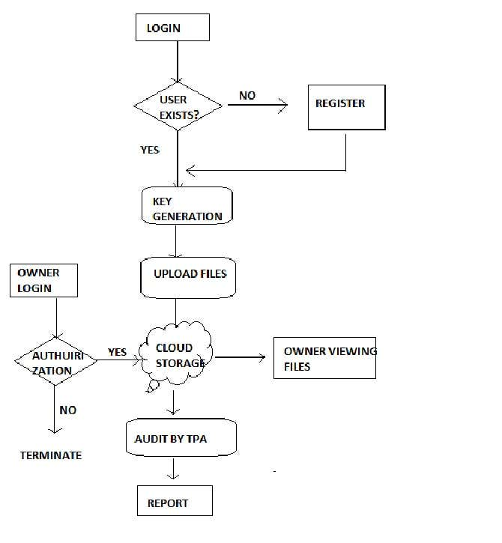
Fig 4.1 ER diagram

  - DATA DICTIONARY
A data dictionary, or metadata repository, as defined in the IBM Dictionary of Computing, is a "centralized repository of information about data such as meaning, relationships to other data, origin, usage, and format". Oracle defines it as a collection of tables with metadata. The term can have one of several closely related meanings pertaining to databases and database management systems (DBMS):
- A document describing a database or collection of databases
- An integral component of a DBMS that is required to determine its structure
- A piece of middleware that extends or supplants the native data dictionary of a DBMS

User:

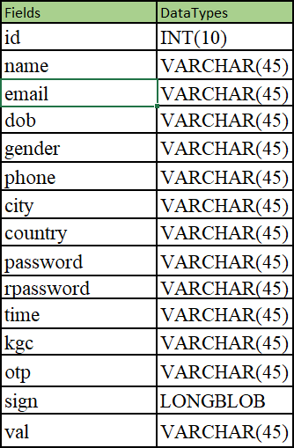

Table 4.1 data dictionary of user

    - FILEUPLOAD:
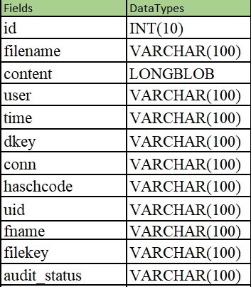

Table 4.2 Data dictionary of file Upload

    - CLOUD_REQUEST:

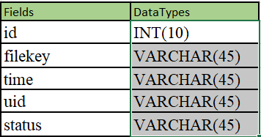

Table 4.3 Data dictionary of Cloud Request

    - AUDIT_REQUEST:

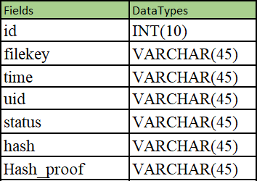

Table 4.4 Data dictionary of Audit Request

  - DATA FLOW DIAGRAM

A picture is worth a thousand words. A Data Flow Diagram (DFD) is traditional visual representation of the information flows within a system. A neat and clear DFD can depict a good amount of the system requirements graphically. It can be manual, automated, or combination of both. It shows how information enters and leaves the system, what changes the information and where information is stored. The purpose of a DFD is to show the scope and boundaries of a system as a whole. It may be used as a communications tool between a systems analyst and any person who plays a part in the system that acts as the starting point for redesigning a system.

It is usually beginning with a context diagram as the level 0 of DFD diagram, a simple representation of the whole system. To elaborate further from that, we drill down to a level 1 diagram with lower level functions decomposed from the major

functions of the system. This could continue to evolve to become a level 2 diagram when further analysis is required. Progression to level 3, 4 and so on is possible but anything beyond level 3 is not very common. Please bear in mind that the level of details for decomposing function really depending on the complexity that function.
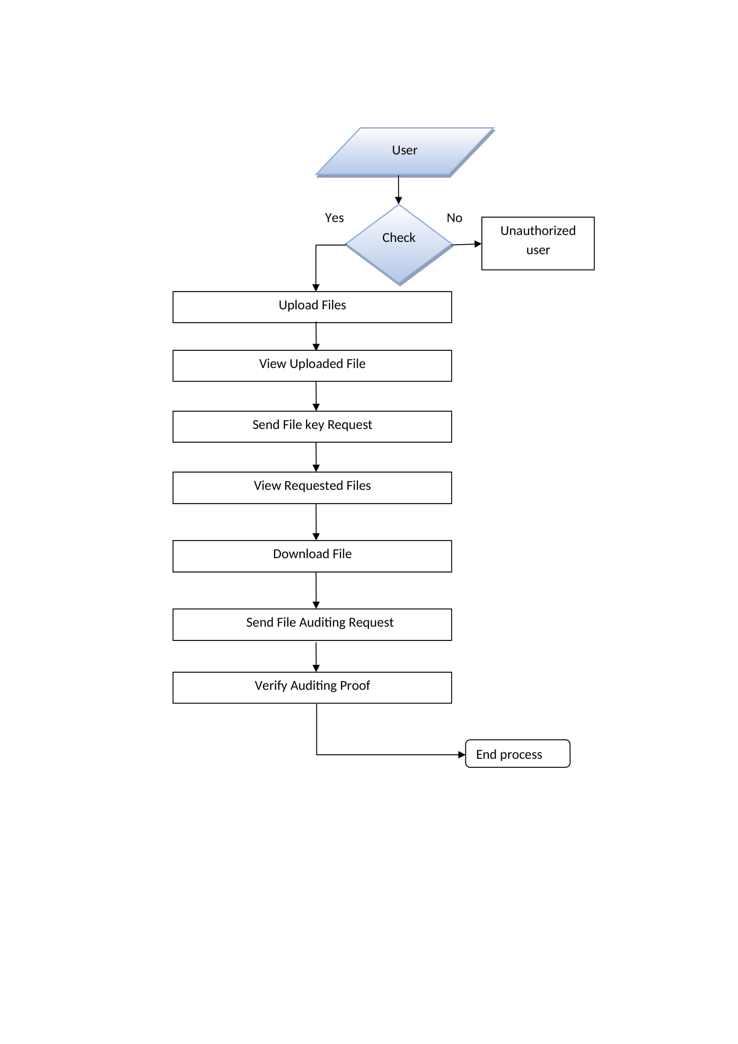

Fig 4.2 Data flow diagram of user

Unauthorized user

TPA
Check
Receive Auditing Request
Send Auditing Request To Cloud
View Hash code
End process

Fig 4.3 Data flow diagram of TPA

Unauthorized user

Cloud Login
Check
Send Auditing Proof
View Cloud Files
Performance Analysis
End process

Fig 4.4 Data flow diagram of cloud server

UML DIAGRAMS
UML stands for Unified Modeling Language. It’s a rich language to model software solutions, application structures, system behavior and business processes. There are 14 UML diagram types to help you model these behaviors. Unified Modeling Language™ (UML®) is a standard visual modeling language intended to be used for
- modeling business and similar processes,
- analysis, design, and implementation of software-based systems

UML is a common language for business analysts, software architects and developers used to describe, specify, design, and document existing or new business processes, structure and behavior of artifacts of software systems.
Specification explained that process:
- provides guidance as to the order of a team’s activities,
- specifies what artifacts should be developed,
- directs the tasks of individual developers and the team as a whole, and
- offers criteria for monitoring and measuring a project’s products and activities.

UML is intentionally process independent and could be applied in the context of different processes. Still, it is most suitable for use case driven, iterative and incremental development processes. An example of such process is Rational Unified Process (RUP). UML is not complete, and it is not completely visual. Given some UML diagram, we can't be sure to understand depicted part or behavior of the system from the diagram alone. Some information could be intentionally omitted from the diagram, some information represented on the diagram could have different interpretations, and some concepts of UML have no graphical notation at all, so there is no way to depict those on diagrams. For example, semantics of multiplicity of actors and multiplicity of use cases on use case diagrams is not defined precisely in the UML specification and could mean either concurrent or successive usage of use cases.

Name of an abstract classifier is shown in italics while final classifier has no specific graphical notation, so there is no way to determine whether classifier is final or not from the diagram.

List of UML Diagram Types
So, what are the different UML diagram types? There are two main categories; structure diagrams and behavioral diagrams. Click on the links to learn more about a specific diagram type.

Structure Diagrams

Structure diagrams show the things in the modeled system. In a more technical term, they show different objects in a system. Behavioral diagrams show what should happen in a system. They describe how the objects interact with each other to create a functioning system.

Class Diagram
Class diagrams are the main building block of any object-oriented solution. It shows the classes in a system, attributes, and operations of each class and the relationship between each class. In most modeling tools, a class has three parts. Name at the top, attributes in the middle and operations or methods at the bottom.

In a large system with many related classes, classes are grouped together to create class diagrams. Different relationships between classes are shown by different types of arrows.

Component Diagram
A component diagram displays the structural relationship of components of a software system. These are mostly used when working with complex systems with many components. Components communicate with each other using interfaces. The interfaces are linked using connectors. The image below shows a component diagram.

Deployment Diagram
A deployment diagram shows the hardware of your system and the software in that hardware. Deployment diagrams are useful when your software solution is deployed across multiple machines with each having a unique configuration. Below is an example deployment diagram.

Package Diagram
As the name suggests, a package diagram shows the dependencies between different packages in a system. Check out this wiki article to learn more about the dependencies and elements found in package diagrams.

Composite Structure Diagram
Composite structure diagrams are used to show the internal structure of a class. For a detailed explanation of composite structure diagrams.

Use Case Diagram
As the most known diagram type of the behavioral UML diagrams, use case diagrams give a graphic overview of the actors involved in a system, different functions needed by those actors and how these different functions interact.
It’s a great starting point for any project discussion because you can easily identify the main actors involved and the main processes of the system. You can create use case diagrams using our tool and/or get started instantly using our use case templates.

Activity Diagram
Activity diagrams represent workflows in a graphical way. They can be used to describe the business workflow or the operational workflow of any component in a system. Sometimes activity diagrams are used as an alternative to State machine diagrams. Check out this wiki article to learn about symbols and usage of activity diagrams.

Sequence Diagram
Sequence diagrams in UML show how objects interact with each other and the order those interactions occur. It’s important to note that they show the interactions for a scenario. The processes are represented vertically, and interactions are shown as arrows. This article explains the purpose and the basics of Sequence diagrams. Also, check out this complete Sequence Diagram Tutorial to learn more about sequence diagrams. You can also instantly start drawing using our sequence diagram templates.

Fig 4.5 Use case diagram

Fig 4.6 Class diagram

Fig 4.7 Sequence diagram

Fig 4.8 Activity Diagram

CHAPTER 5 ARCHITECTURE

ARCHITECTURE OVERVIEW
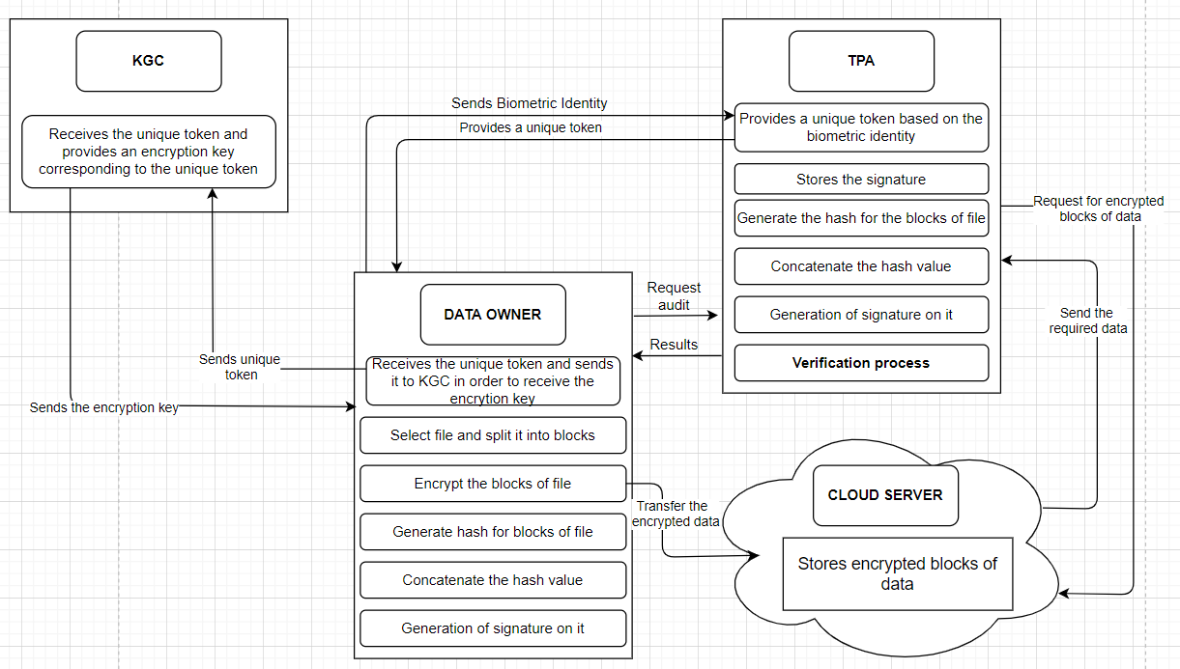
System architecture is the conceptual model that defines the structure, behavior, and more views of a system. An architecture description is a formal description and representation of a system, organized in a way that supports reasoning about the structures and behaviors of the system.

Fig 5.1 System Architecture

SYSTEM MODULE:

The proposed auditing scheme contains 4 modules namely:
    - User
    - Third Party Auditor (TPA)
    - Key Generating Center (KGC)
    - Cloud server

MODULES EXPLANATION:
      - User:

In User module, Initially User must have to register their detail. After successful registration data owner can login and upload files into cloud server with encrypted keywords and hashing algorithms. He/she can view the files that are uploaded in cloud. User can approve or reject the file request sent by other users. After request approval data user will send the secret key and verification object through mail.

THIRD PARTY AUDITOR (TPA):

In TPA module, TPA can receive user file auditing requests and send response to cloud server. Upon receiving the auditing request, TPA and the cloud server execute a challenge-response protocol to verify if the stored file is intact.

KEY GENERATING CENTER (KGC):

In KGC module, KGC can view all user details and has authority to approve users and send secret key to respected user. A cloud user forwards his/her attribute set to KGC to request his/her private key. KGC generates a private key for the user with the master secret key and the user’s attributes

CLOUD SERVER:

In Cloud Server module, Cloud Provider can view all files details. Cloud can audit user files and generate proof to respected User.

CHAPTER 6 TESTING

SYSTEM TESTING
The testing approach document is designed for Information and Technology Services’ upgrades to PeopleSoft. The document contains an overview of the testing activities to be performed when an upgrade or enhancement is made, or a module is added to an existing application. The emphasis is on testing critical business processes, while minimizing the time necessary for testing while also mitigating risks. It’s important to note that reducing the amount of testing done in an upgrade increases the potential for problems after go-live. Management will need to determine how much risk is acceptable on an upgrade by upgrade basis.
System testing is simply testing the system as a whole; it gets all the integrated modules of the various components from the integration testing phase and combines all the different parts into a system which is then tested. Testing is then done on the system as all the parts are now integrated into one system the testing phase will now have to be done on the system to check and remove any errors or bugs. In the system testing process the system will be checked not only for errors but also to see if the system does what was intended, the system functionality and if it is what the end user expected.
There are various tests that need to be conducted again in the system testing which include:

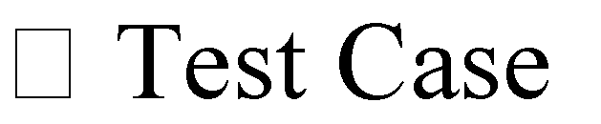
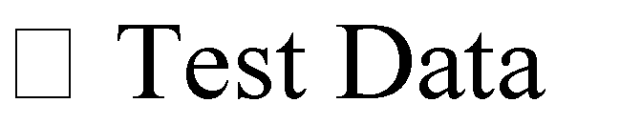

If the integration stage was done accurately then most of the test plan and test cases would already have been done and simple testing would only have to be done in order to ensure there are no bugs because this will be the final product. As in the integration stage, the above steps would need to be re-done as now we have

integrated all modules into one system, so we have to check if this runs OK and that no errors are produced because all the modules are in one system.

Unit Testing
In computer programming, unit testing is a software testing method by which individual units of source code, sets of one or more computer program modules together with associated control data, usage procedures, and operating procedures are tested to determine if they are fit for use. In object-oriented programming, a unit is often an entire interface, such as a class, but could be an individual method. Unit tests are short code fragments created by programmers or occasionally by white box testers during the development process. Ideally, each test case is independent from the others. Substitutes such as method stubs, mock objects, fakes, and test harnesses can be used to assist testing a module in isolation. Unit tests are typically written and run by software developers to ensure that code meets its design and behaves as intended.

TEST CASES

Test Cas e Id | Test Cases | Priorit y | Input Test Data | Test Case Description | Expected Results | Actual Results | Pass/Fail
TC0 1 | User registration | A | Enter user details and biometrics | Add user to database | User should be available in database | User present in database | Pass
TC0 2 | User login | A | Enter emailed and password | Check the user | User should available in database | User present in database | Pass
TC0 3 | OTP Notificatio n | A | - | User enter the OTP for verfication | Notificatio n should be received properly | Mail Message received properly | Pass
TC0 4 | File upload to cloud | A | Enter the file name and select the file | User uploads the file to cloud | Successful uploaded | uploaded successfully | Pass

Table 6.1 Test Cases for User Module

Test Case Id | Test Cases | Priority | Input Test Data | Test Case Description | Expected Results | Actual Results | Pass/Fail
TC0 1 | KGC login | A | Username and password | Verify the KGC login | Kgc login successful | Login success | Pass
TC0 2 | Approve User | A | - | Verify and approve user and send private key to user | Notification should be sent properly | email Message sent properly | Pass

Table 6.2 Test Cases for KGC

Test Case Id | Test Cases | Priority | Input Test Data | Test Case Description | Expected Results | Actual Results | Pass/Fail
TC01 | Cloud login | A | Enter Email-id and  Password. | Verify the cloud user | Cloud login successful | Login success | Pass
TC02 | List of Files in cloud | A | - | Uploaded files should be displayed | Should display with hash value | Displayed with hash value | Pass

Table 6.3 Test Cases for Cloud Server Module

CHAPTER 7
CONCLUSION

CONCLUSION

Cloud storage services have become an increasingly important part of the information technology industry in recent years. Thus, ensuring the integrity of data outsourced to the cloud is of paramount importance. In this paper, we presented the biometric based data integrity auditing protocol. The proposed protocol revolutionizes key management in traditional remote data integrity checking protocols. We also presented the the system and security models for this primitive, and a concrete biometric based data integrity auditing protocol using the biometric based identity as an input. We then demonstrated the security of the protocol in the selective-ID model. The prototype implementation of the protocol demonstrates the practicality of the proposal. The existing system is designed in such a way that the data owner submits his/her biometric identity to the KGC in order to receive the encryption key which may lead to security problem as the KGC knows both the biometric identity and the encryption key which can then be used by attackers to access user’s cloud data, So we proposed a secure and privacy auditing scheme which uses the concept of token, The idea is that the data owner submits his/her biometric identity to the TPA and then the TPA returns a unique token to the user based on the biometric received. The data owner then sends the unique token to the KGC in order to receive the encryption key, as a result the KGC only knows the unique token and the encryption key, So the attacker can never know which user uses which unique token.

APPENDICES

A1. SAMPLE SCREENS

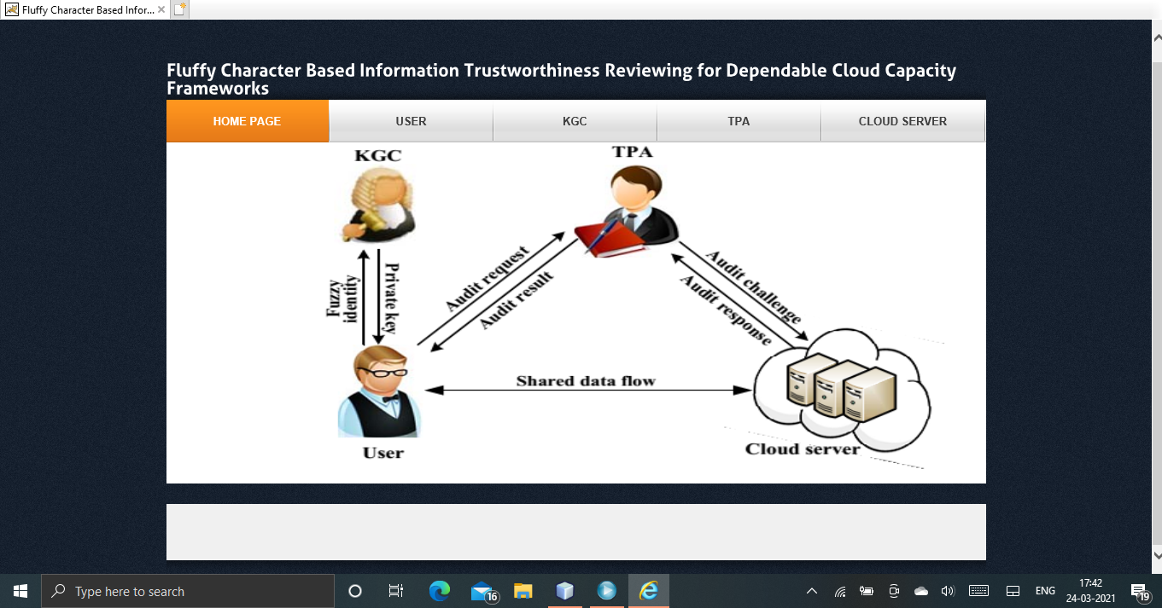

Fig.1 Home Page
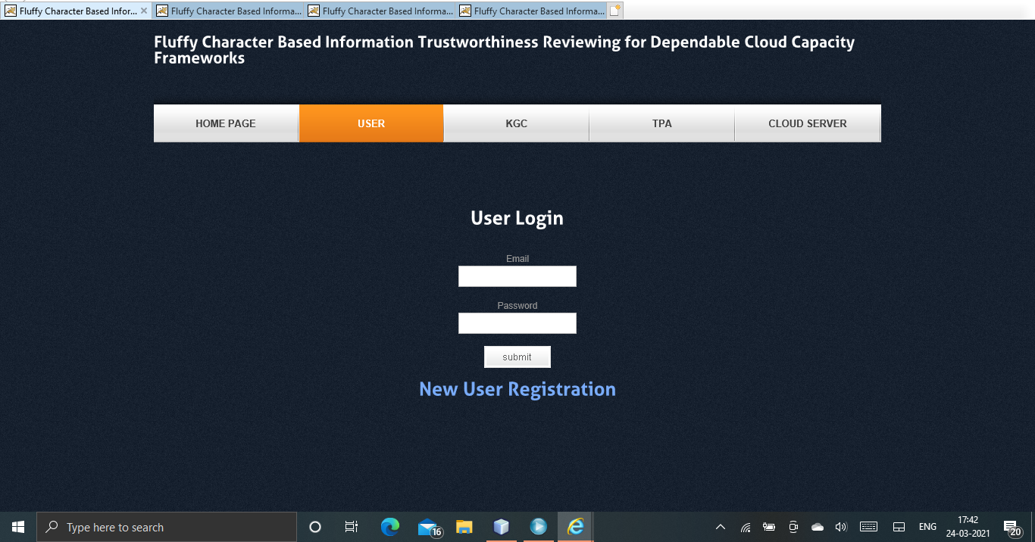

Fig.2 User Log-In

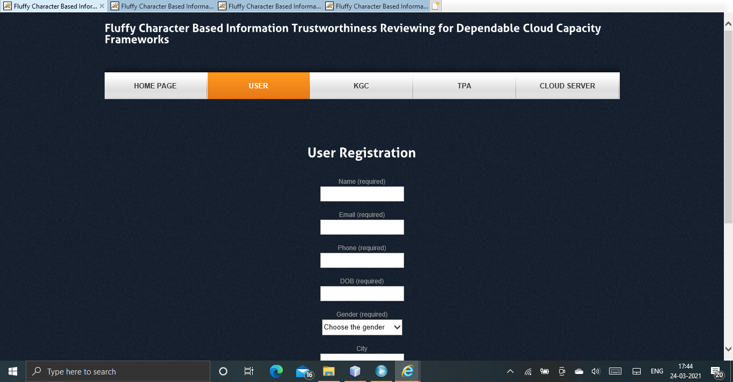

Fig.3 User Registration
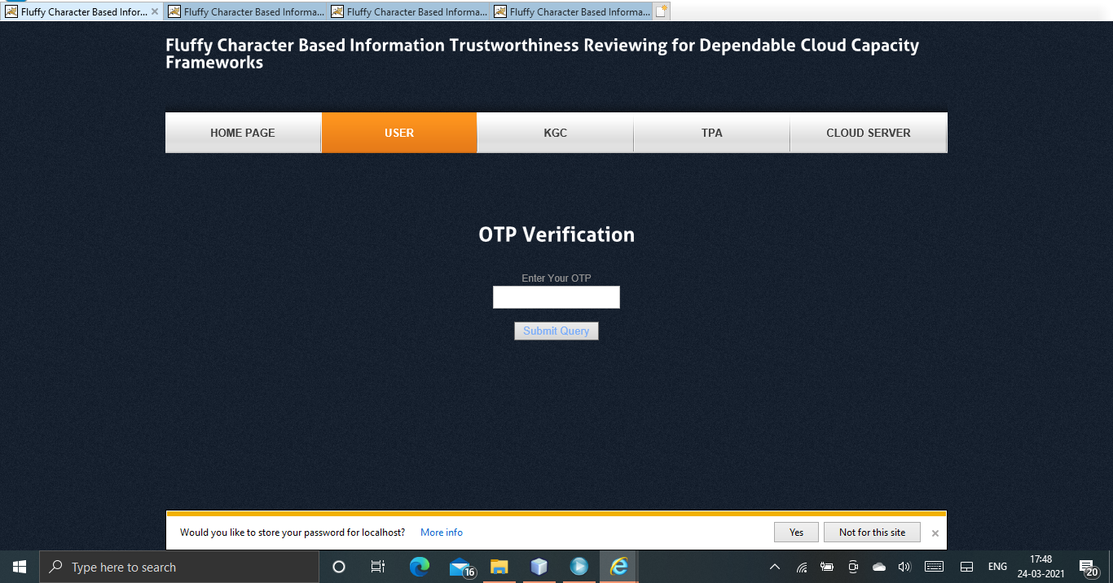

Fig.4 OTP Verification

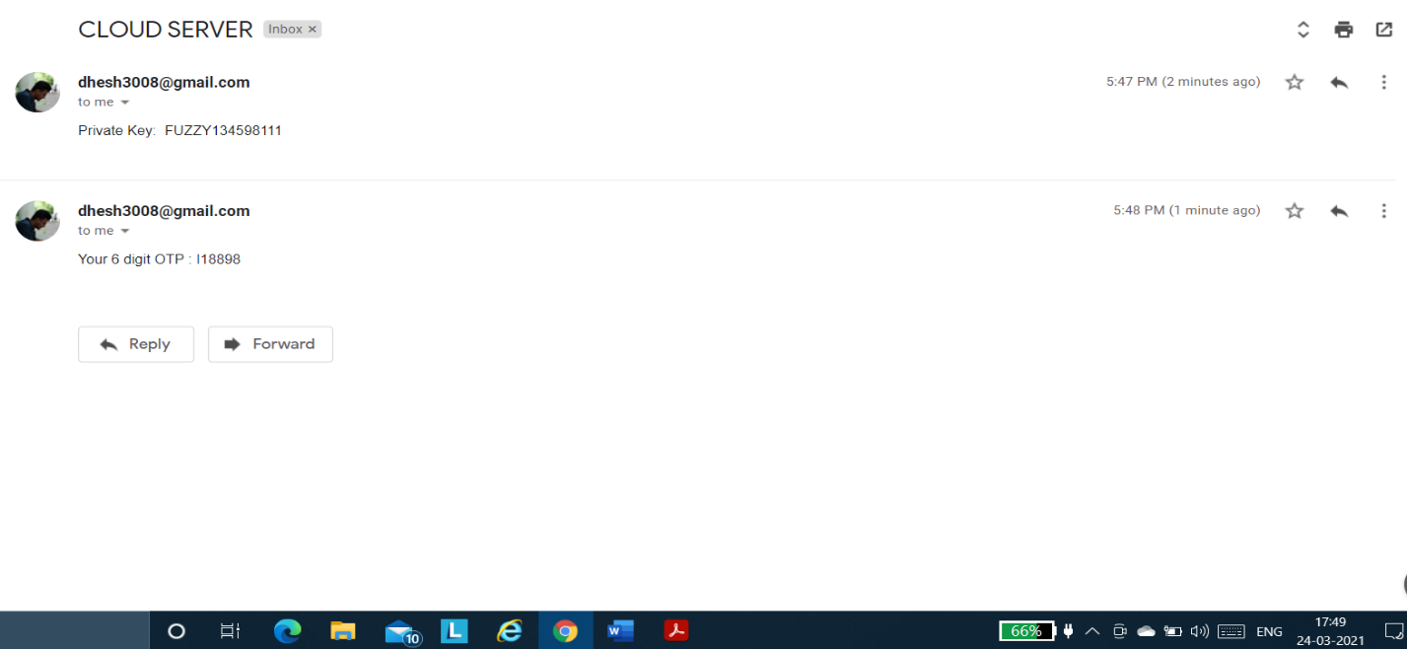

Fig.5 OTP Sent to Mail

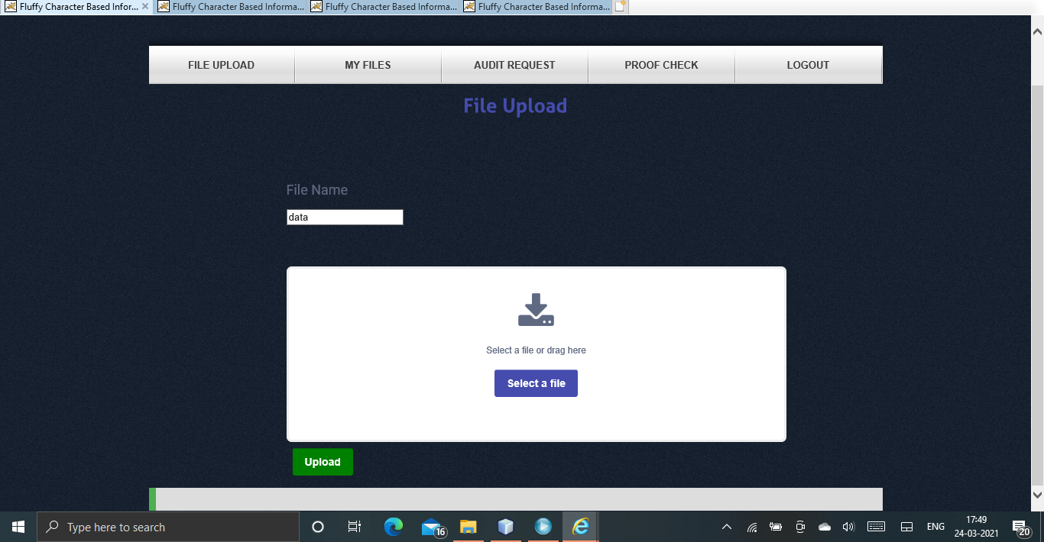

Fig.6 File Upload

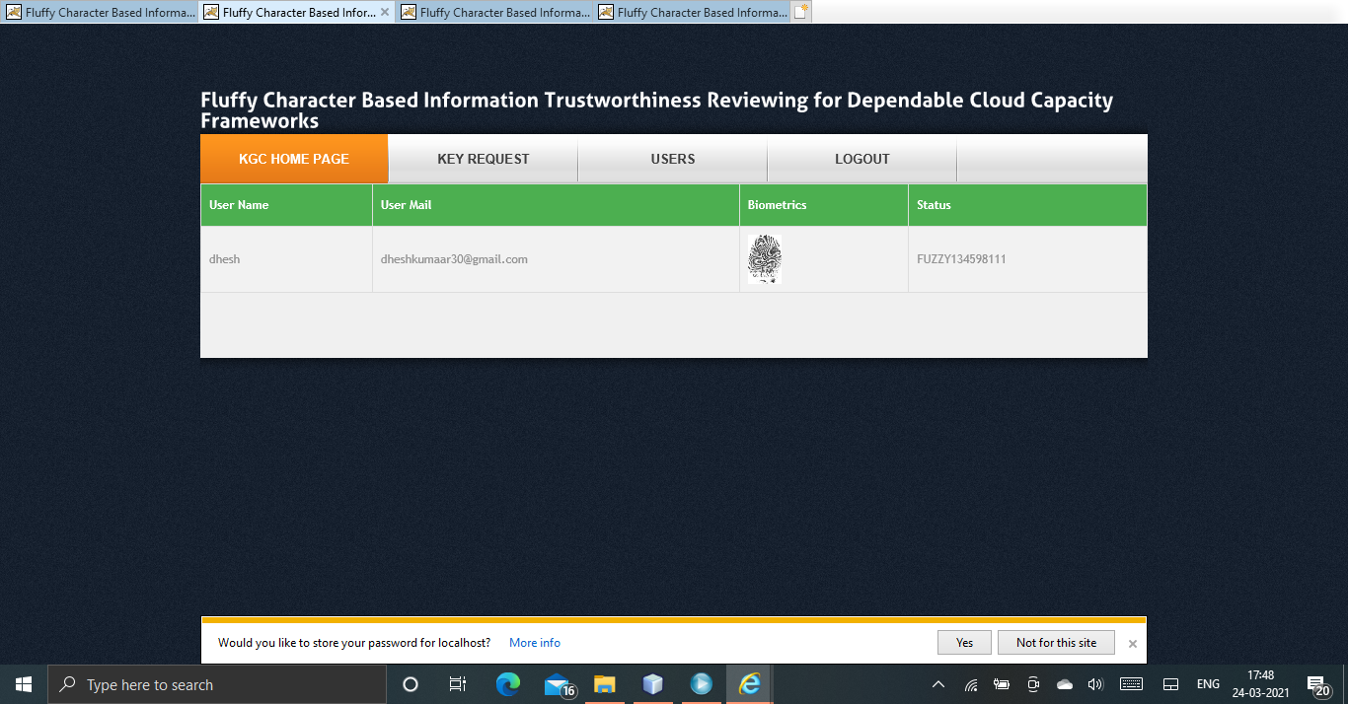

Fig.7 KGC Dashboard
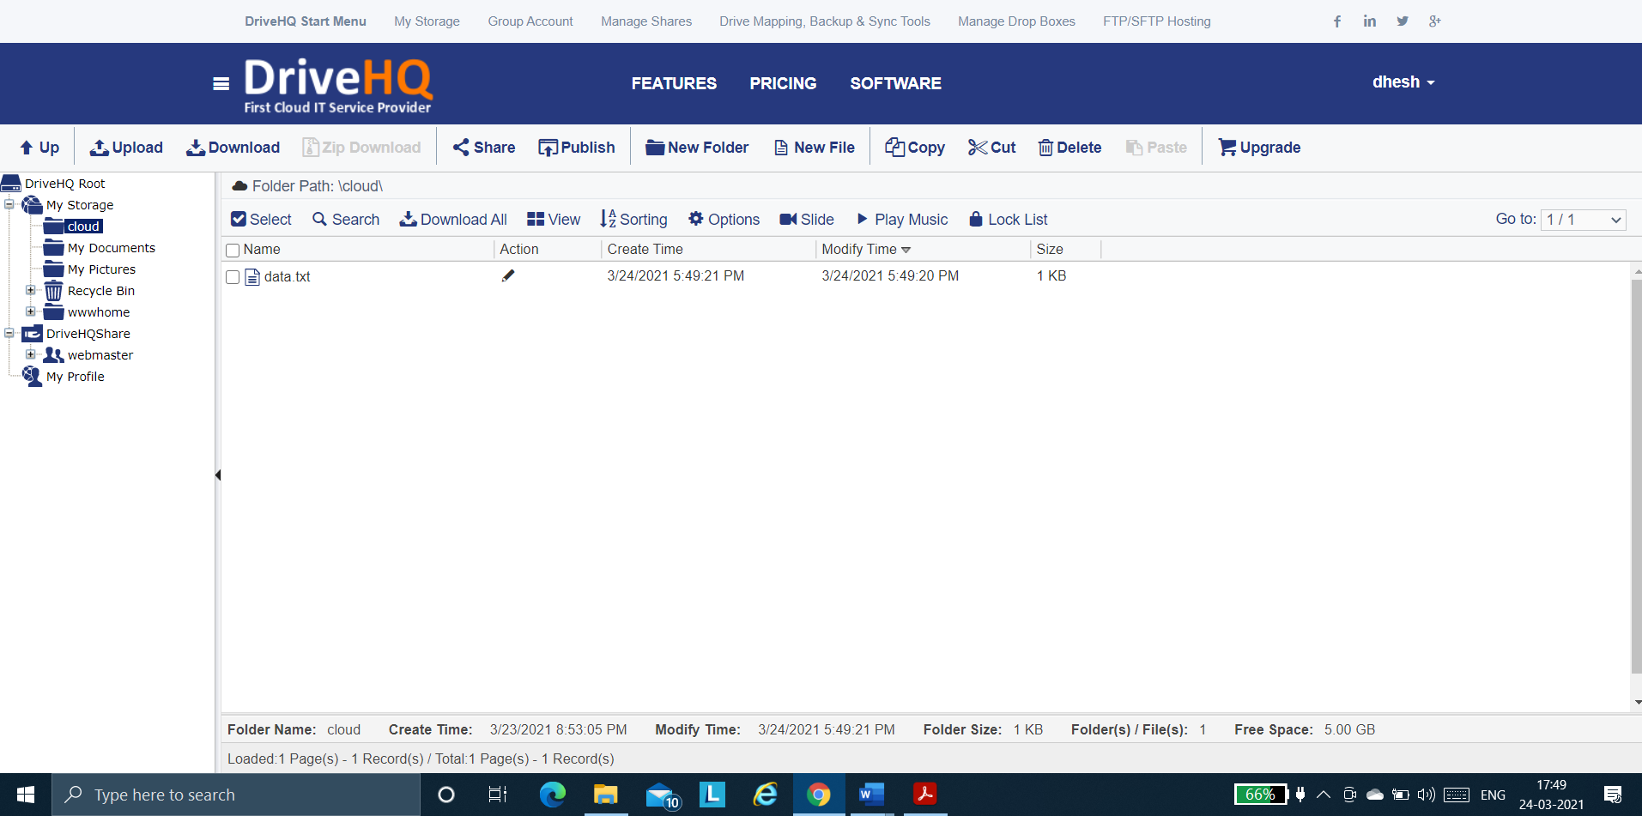

Fig.8 File Uploaded in Real Time Cloud (DriveHQ)

A2. SAMPLE CODE
Server-Side:
FTPcon.java

package FUZZY;

import java.io.File;
import java.io.FileInputStream;
import org.apache.commons.net.ftp.FTPClient;

public class FTPcon {

FTPClient client = new FTPClient();
FileInputStream fis = null;
boolean status;

/**
*
* @param file
* @return
*/
public boolean upload(File file) {
try {
System.out.println("Check------------------------------------->1");
client.connect("ftp.drivehq.com");
client.login("CloudComputing", "publicclouds");
client.enterLocalPassiveMode();
fis = new FileInputStream(file);
System.out.println("Check------------------------------------->2");
status = client.storeFile("/cloud/" + file.getName(), fis);
//file path of drive storage
client.logout();
fis.close();

} catch (Exception e) {
System.out.println(e);
}
if (status) {
System.out.println("success");
return true;
} else {
System.out.println("failed");
return false;

}

}
}

KGC.java

package FUZZY;

import java.io.IOException;
import java.io.PrintWriter;
import javax.servlet.ServletException;
import javax.servlet.http.HttpServlet;
import javax.servlet.http.HttpServletRequest;
import javax.servlet.http.HttpServletResponse;

public class KGC extends HttpServlet {

protected void processRequest(HttpServletRequest request, HttpServletResponse response)
throws ServletException, IOException {
response.setContentType("text/html;charset=UTF-8");
PrintWriter out = response.getWriter();
try {
String name = request.getParameter("kgcid");
String pass = request.getParameter("password");
System.out.println("=======================================" +name +pass);
if (name.equals("kgc") && pass.equals("kgc")) {
response.sendRedirect("KGC_home.jsp?success");
} else {
response.sendRedirect("KGC.jsp?failed");
}
} catch (Exception ex) {
}
}
@Override
protected void doGet(HttpServletRequest request, HttpServletResponse response)
throws ServletException, IOException {
processRequest(request, response);
}

@Override
protected void doPost(HttpServletRequest request, HttpServletResponse response)
throws ServletException, IOException {
processRequest(request, response);
}

@Override
public String getServletInfo() {
return "Short description";
}
}

Mail.java

package FUZZY;

import java.util.Properties;
import javax.mail.Message;
import javax.mail.MessagingException;
import javax.mail.PasswordAuthentication;
import javax.mail.Session;
import javax.mail.Transport;
import javax.mail.internet.InternetAddress;
import javax.mail.internet.MimeMessage;

public class Mail {

public static boolean secretMail(String msg, String name, String email) {
Properties props = new Properties();
props.put("mail.smtp.host", "smtp.gmail.com");
props.put("mail.smtp.socketFactory.port", "465");

props.put("mail.smtp.socketFactory.class",
"javax.net.ssl.SSLSocketFactory");
props.put("mail.smtp.auth", "true");
props.put("mail.smtp.port", "465");
// Assuming you are sending email from localhost
Session session = Session.getDefaultInstance(props,
new javax.mail.Authenticator() {
protected PasswordAuthentication getPasswordAuthentication() {
return new PasswordAuthentication("cloudcomputing@gmail.com","mailpassword");
}
});

System.out.println("Message" + msg);
try {
Message message = new MimeMessage(session);
message.setFrom(new InternetAddress(name));
message.setRecipients(Message.RecipientType.TO,
InternetAddress.parse(email));
message.setSubject("CLOUD SERVER");
message.setText(""+msg);

Transport.send(message);

System.out.println("Done");
return true;

} catch (MessagingException e) {
System.out.println(e);
e.printStackTrace();
return false;
// throw new RuntimeException(e);
}
}
}

SQLconnection.java

package FUZZY;

import java.sql.Connection;
import java.sql.DriverManager;

public class SQLconnection {

static Connection con;
public static Connection getconnection() {
try {
Class.forName("com.mysql.jdbc.Driver");
con = DriverManager.getConnection("jdbc:mysql://localhost:3306/fuzzy", "root", "root");
} catch (Exception e) {
}
return con;
}
}

TPA.java

package FUZZY;

import java.io.IOException;
import java.io.PrintWriter;
import javax.servlet.ServletException;
import javax.servlet.http.HttpServlet;
import javax.servlet.http.HttpServletRequest;
import javax.servlet.http.HttpServletResponse;

public class TPA extends HttpServlet {

protected void processRequest(HttpServletRequest request, HttpServletResponse response)
throws ServletException, IOException {
response.setContentType("text/html;charset=UTF-8");
PrintWriter out = response.getWriter();
try {
String name = request.getParameter("tpa");
String pass = request.getParameter("password");
System.out.println("=======================================" +name +pass);
if (name.equals("tpa") && pass.equals("tpa")) {
response.sendRedirect("TPA_home.jsp?success");
} else {
response.sendRedirect("TPAlog.jsp?failed");
}
} catch (Exception ex) {
}
}

@Override
protected void doGet(HttpServletRequest request, HttpServletResponse response)
throws ServletException, IOException {
processRequest(request, response);
}
@Override
protected void doPost(HttpServletRequest request, HttpServletResponse response)
throws ServletException, IOException {
processRequest(request, response);
}

/**
* Returns a short description of the servlet.
*
* @return a String containing servlet description
*/
@Override
public String getServletInfo() {
return "Short description";
}// </editor-fold>
}

Upload.java

package FUZZY;

import com.oreilly.servlet.MultipartRequest;
import com.sun.org.apache.xerces.internal.impl.dv.util.Base64;
import java.io.BufferedReader;
import java.io.File;
import java.io.FileReader;
import java.io.FileWriter;
import java.io.IOException;
import java.io.PrintWriter;
import java.security.SecureRandom;
import java.sql.Connection;
import java.sql.Statement;
import java.text.DateFormat;
import java.text.SimpleDateFormat;
import java.util.Date;
import java.util.Random;
import javax.crypto.KeyGenerator;
import javax.crypto.SecretKey;
import javax.servlet.ServletException;
import javax.servlet.http.HttpServlet;
import javax.servlet.http.HttpServletRequest;
import javax.servlet.http.HttpServletResponse;
import javax.servlet.http.HttpSession;

public class Upload extends HttpServlet {

File file;
final String filepath = "D:/";

protected void processRequest(HttpServletRequest request, HttpServletResponse response)
throws ServletException, IOException {
response.setContentType("text/html;charset=UTF-8");
PrintWriter out = response.getWriter();
try {
MultipartRequest m = new MultipartRequest(request, filepath);
String fname = m.getParameter("fname");
File file = m.getFile("data");
String filename = file.getName().toLowerCase();

Connection con = SQLconnection.getconnection();

BufferedReader br = new BufferedReader(new FileReader(filepath + filename));
StringBuffer sb = new StringBuffer();
String temp = null;

while ((temp = br.readLine()) != null) {
sb.append(temp);
}

KeyGenerator Attrib_key = KeyGenerator.getInstance("AES");
Attrib_key.init(128);
SecretKey secretKey = Attrib_key.generateKey();
System.out.println("++++++++ key:" + secretKey);

Encryption e = new Encryption();
String encryptedtext = e.encrypt(sb.toString(), secretKey);
//storing encrypted file
FileWriter fw = new FileWriter(file);
fw.write(encryptedtext);
int hash1 =encryptedtext.hashCode();
fw.close();
byte[] b = secretKey.getEncoded();
String Dkey = Base64.encode(b);
System.out.println("converted secretkey to string:" + Dkey);

HttpSession user = request.getSession(true);
String uname = user.getAttribute("uname").toString();
String uid = user.getAttribute("uid").toString();

DateFormat dateFormat = new SimpleDateFormat("yyyy/MM/dd HH:mm:ss");
Date date = new Date();
String time = dateFormat.format(date);
System.out.println("current Date " + time);

boolean status = new FTPcon().upload(file);
if (status) {

Statement st = con.createStatement();
Random RANDOM = new SecureRandom();
int PASSWORD_LENGTH = 7;
String letters = "0123456789";
String fileid = "";
for (int i = 0; i < PASSWORD_LENGTH; i++) {
int index = (int) (RANDOM.nextDouble() * letters.length());
fileid += letters.substring(index, index + 1);
}
String filekey = "file" + fileid;
System.out.println("File Key:------- "+filekey);
System.out.println("Check------------------------------------------------------------------>>>>>");

int i = st.executeUpdate("insert into fileupload(filename,content,user,time,dkey,conn,hashcode,uid, fname,filekey,audit_status)values('" + file.getName() + "','" + encryptedtext + "','" + uname + "','" + time + "','" + Dkey + "','"+sb.toString()+"', '"+hash1+"', '"+ uid +"','"+ fname +"','"+ filekey +"','Not Audited Yet')");
if (i != 0) {
response.sendRedirect("File_Upload.jsp?Successful");

} else {
System.out.println("Error in SQL Syntex");
}
}
} catch (Exception e) {
out.println(e);
} finally {
out.close();
}
}
@Override
protected void doGet(HttpServletRequest request, HttpServletResponse response)
throws ServletException, IOException {
processRequest(request, response);
}

@Override
protected void doPost(HttpServletRequest request, HttpServletResponse response)
throws ServletException, IOException {
processRequest(request, response);
}

@Override
public String getServletInfo() {
return "Short description";
}// </editor-fold>
}
signup.java

package FUZZY;

import java.awt.Image;
import java.io.ByteArrayInputStream;
import java.io.ByteArrayOutputStream;
import java.io.IOException;
import java.io.InputStream;
import java.net.URL;
import java.security.SecureRandom;
import java.sql.Connection;
import java.sql.DriverManager;
import java.sql.PreparedStatement;
import java.sql.SQLException;
import java.text.DateFormat;
import java.text.SimpleDateFormat;
import java.util.Date;
import java.util.Random;
import javax.imageio.ImageIO;

import javax.servlet.ServletException;
import javax.servlet.annotation.MultipartConfig;
import javax.servlet.annotation.WebServlet;
import javax.servlet.http.HttpServlet;
import javax.servlet.http.HttpServletRequest;
import javax.servlet.http.HttpServletResponse;
import javax.servlet.http.HttpSession;
import javax.servlet.http.Part;

@WebServlet("/signup")
@MultipartConfig(maxFileSize = 16177215)
public class signup extends HttpServlet {

private String dbURL = "jdbc:mysql://localhost:3306/fuzzy";
private String dbUser = "root";
private String dbPass = "root";
private SimpleDateFormat format;

protected void doPost(HttpServletRequest request,
HttpServletResponse response) throws ServletException, IOException {

HttpSession session = request.getSession(true);

String name = request.getParameter("name");
String mail = request.getParameter("email");
String dob = request.getParameter("dob");
String gender = request.getParameter("gender");
String phone = request.getParameter("phone");
String city = request.getParameter("city");
String country = request.getParameter("country");
String pass = request.getParameter("password");
String rpass = request.getParameter("rpassword");
String kgc = "waiting";
String otp = "waiting";
DateFormat dateFormat = new SimpleDateFormat("YYYY/MM/dd HH:mm:ss");
Date date = new Date();
String time = dateFormat.format(date);
InputStream inputStream = null;
Part filePart = request.getPart("bio_sign");
long value=filePart.getSize();
String val= String.valueOf(value);
if (filePart != null) {
System.out.println(filePart.getName());
System.out.println(val);
System.out.println(filePart.getContentType());
inputStream = filePart.getInputStream();
}
Connection conn = null;
String message = null;
try {

DriverManager.registerDriver(new com.mysql.jdbc.Driver());
conn = DriverManager.getConnection(dbURL, dbUser, dbPass);

String sql = "insert into user(name, email, dob, gender, phone, city, country, password, rpassword, time , kgc, otp, sign,val) values(?, ?, ?, ?, ?, ?, ?,?,?,?,?,?,?,?)";
PreparedStatement statement = conn.prepareStatement(sql);
statement.setString(1, name);
statement.setString(2, mail);
statement.setString(3, dob);
statement.setString(4, gender);
statement.setString(5, phone);
statement.setString(6, city);
statement.setString(7, country);
statement.setString(8, pass);
statement.setString(9, rpass);
statement.setString(10, time);
statement.setString(11, kgc);
statement.setString(12, otp);
statement.setString(14, val);

if (inputStream != null) {
statement.setBlob(13, inputStream);
}
// statement.setString(8, otp);
int row = statement.executeUpdate();
if (row > 0) {

response.sendRedirect("User.jsp?Successful");
} else {
response.sendRedirect("User_reg.jsp?failed");
}
} catch (SQLException ex) {
ex.printStackTrace();
}
}
}

Client - Side

script_1.js

// File Upload
//
function ekUpload(){
function Init() {

console.log("Upload Initialised");

var fileSelect = document.getElementById('file-upload'),
fileDrag = document.getElementById('file-drag'),
submitButton = document.getElementById('submit-button');

fileSelect.addEventListener('change', fileSelectHandler, false);

// Is XHR2 available?
var xhr = new XMLHttpRequest();
if (xhr.upload) {
// File Drop
fileDrag.addEventListener('dragover', fileDragHover, false);
fileDrag.addEventListener('dragleave', fileDragHover, false);
fileDrag.addEventListener('drop', fileSelectHandler, false);
}
}

function fileDragHover(e) {
var fileDrag = document.getElementById('file-drag');

e.stopPropagation();
e.preventDefault();

fileDrag.className = (e.type === 'dragover' ? 'hover' : 'modal-body file-upload');
}

function fileSelectHandler(e) {
// Fetch FileList object
var files = e.target.files || e.dataTransfer.files;

// Cancel event and hover styling
fileDragHover(e);

// Process all File objects
for (var i = 0, f; f = files[i]; i++) {
parseFile(f);
uploadFile(f);
}
}

// Output
function output(msg) {
// Response
var m = document.getElementById('messages');
m.innerHTML = msg;
}

function parseFile(file) {

console.log(file.name);
output(
'<strong>' + encodeURI(file.name) + '</strong>'
);

// var fileType = file.type;
// console.log(fileType);
var imageName = file.name;

var isGood = (/\.(?=gif|jpg|png|jpeg)/gi).test(imageName);
if (isGood) {
document.getElementById('start').classList.add("hidden");
document.getElementById('response').classList.remove("hidden");
document.getElementById('notimage').classList.add("hidden");
// Thumbnail Preview
document.getElementById('file-image').classList.remove("hidden");
document.getElementById('file-image').src = URL.createObjectURL(file);
}
else {
document.getElementById('file-image').classList.add("hidden");
document.getElementById('notimage').classList.remove("hidden");
document.getElementById('start').classList.remove("hidden");
document.getElementById('response').classList.add("hidden");
document.getElementById("file-upload-form").reset();
}
}

function setProgressMaxValue(e) {
var pBar = document.getElementById('file-progress');

if (e.lengthComputable) {
pBar.max = e.total;
}
}

function updateFileProgress(e) {
var pBar = document.getElementById('file-progress');

if (e.lengthComputable) {
pBar.value = e.loaded;
}
}

function uploadFile(file) {

var xhr = new XMLHttpRequest(),
fileInput = document.getElementById('class-roster-file'),
pBar = document.getElementById('file-progress'),
fileSizeLimit = 1024; // In MB
if (xhr.upload) {
// Check if file is less than x MB
if (file.size <= fileSizeLimit * 1024 * 1024) {
// Progress bar
pBar.style.display = 'inline';
xhr.upload.addEventListener('loadstart', setProgressMaxValue, false);
xhr.upload.addEventListener('progress', updateFileProgress, false);

// File received / failed
xhr.onreadystatechange = function(e) {
if (xhr.readyState == 4) {
// Everything is good!

// progress.className = (xhr.status == 200 ? "success" : "failure");
// document.location.reload(true);
}
};

// Start upload
xhr.open('POST', document.getElementById('file-upload-form').action, true);
xhr.setRequestHeader('X-File-Name', file.name);
xhr.setRequestHeader('X-File-Size', file.size);
xhr.setRequestHeader('Content-Type', 'multipart/form-data');
xhr.send(file);
} else {
output('Please upload a smaller file (< ' + fileSizeLimit + ' MB).');
}
}
}

// Check for the various File API support.
if (window.File && window.FileList && window.FileReader) {
Init();
} else {
document.getElementById('file-drag').style.display = 'none';
}
}
ekUpload();

validation.js

function checkForm(form)
{
if(form.username.value == "") {
alert("Error: File ID cannot be blank!");
form.username.focus();
return false;
}
if(form.pwd1.value != "" && form.pwd1.value == form.pwd2.value) {
if(form.pwd1.value.length < 6) {
alert("Error: Password must contain at least six characters!");
form.pwd1.focus();
return false;
}
if(form.pwd1.value == form.username.value) {
alert("Error: Password must be different from Username!");
form.pwd1.focus();
return false;
}
} else {
alert("Incorrect Hash Values");
form.pwd1.focus();
return false;
}

alert("Hash value Matches.. : " + form.pwd1.value);
return true;
}

All_files.jsp

<%@page import="java.sql.ResultSet"%>
<%@page import="java.sql.Statement"%>
<%@page import="java.sql.Connection"%>
<%@page import="FUZZY.SQLconnection"%>
<%@page contentType="text/html" pageEncoding="UTF-8"%>
<!DOCTYPE html PUBLIC "-//W3C//DTD XHTML 1.0 Transitional//EN" "http://www.w3.org/TR/xhtml1/DTD/xhtml1-transitional.dtd">
<html xmlns="http://www.w3.org/1999/xhtml">
<head>
<title>Fluffy Character Based Information Trustworthiness </title>
<meta http-equiv="Content-Type" content="text/html; charset=utf-8" />
<link href="css/style.css" rel="stylesheet" type="text/css" />

<link rel="stylesheet" type="text/css" href="css/coin-slider.css" />
<script type="text/javascript" src="js/cufon-yui.js"></script>
<script type="text/javascript" src="js/cufon-aller-700.js"></script>
<script type="text/javascript" src="js/jquery-1.4.2.min.js"></script>
<script type="text/javascript" src="js/script.js"></script>
<script type="text/javascript" src="js/script_1.js"></script>
<script type="text/javascript" src="js/coin-slider.min.js"></script>
</head>
<style>
#customers {
font-family: "Trebuchet MS", Arial, Helvetica, sans-serif;
border-collapse: collapse;
width: 100%;
}

#customers td, #customers th {
border: 1px solid #ddd;
padding: 8px;
}

#customers tr:nth-child(even){background-color: #f2f2f2;}

#customers tr:hover {background-color: #ddd;}

#customers th {
padding-top: 12px;
padding-bottom: 12px;
text-align: left;
background-color: #4CAF50;
color: white;
}
</style>

<%
if (request.getParameter("success") != null) {
%>
<script>alert('Cloud login successful');</script>
<% }
%>
<body>
<div class="main">
<div class="header">
<div class="header_resize">
<div class="searchform">
</div>
<div class="logo">
<h1><a href="index.html"><span>Fluffy Character Based Information</span> <small>Trustworthiness Reviewing for Dependable Cloud Capacity Frameworks</small></a></h1>
</div>
<div class="clr"></div>
<div class="menu_nav">
<ul>
<li><a href="cloud_audit.jsp"><span>Send Proof</span></a></li>
<li><a href="All_files.jsp"><span>Files In Cloud</span></a></li>
<li><a href="index.jsp"><span>Logout</span></a></li>
</ul>
</div>
<div class="clr"></div>
<div class="slider">
<table id="customers">
<tr>
<th>User ID</th>
<th>FILE ID</th>
<th>TIME</th>
<th>HASH VALUE</th>
</tr>
<%
Connection con = SQLconnection.getconnection();
Statement st = con.createStatement();
try {
ResultSet rs = st.executeQuery("Select * from fileupload");
while (rs.next()) {
%>
<tr>
<td data-th="Movie Title"><%=rs.getString("uid")%></td>
<td data-th="Genre"><%=rs.getString("filekey")%></td>
<td data-th="Genre"><%=rs.getString("time")%></td>
<td data-th="Genre"><%=rs.getString("hashcode")%></td>
</tr>
<% }
} catch (Exception ex) {
ex.printStackTrace();
}

%>
</table></center>
<br>
<br>
<br>
<div class="clr"></div>
</div>
<div class="clr"></div>
</div>
</div>
<div class="content">
<div class="content_resize">
<div class="mainbar">
<div class="article">
<div class="clr"></div>
<div class="clr"></div>
</div>
</div>
<div class="sidebar">
</div>
<div class="clr"></div>
</div>
</div>
<div class="footer">
<div class="footer_resize">
<div style="clear:both;"></div>
</div>
</div>
</div>
</body>
</html>

Cloud.jsp

<%@page contentType="text/html" pageEncoding="UTF-8"%>
<!DOCTYPE html PUBLIC "-//W3C//DTD XHTML 1.0 Transitional//EN" "http://www.w3.org/TR/xhtml1/DTD/xhtml1-transitional.dtd">
<html xmlns="http://www.w3.org/1999/xhtml">
<head>
<title>Fluffy Character Based Information Trustworthiness Reviewing</title>
<meta http-equiv="Content-Type" content="text/html; charset=utf-8" />
<link href="css/style.css" rel="stylesheet" type="text/css" />
<link rel="stylesheet" type="text/css" href="css/coin-slider.css" />
<script type="text/javascript" src="js/cufon-yui.js"></script>
<script type="text/javascript" src="js/cufon-aller-700.js"></script>
<script type="text/javascript" src="js/jquery-1.4.2.min.js"></script>
<script type="text/javascript" src="js/script.js"></script>
<script type="text/javascript" src="js/coin-slider.min.js"></script>
</head>
<body>
<div class="main">
<div class="header">
<div class="header_resize">
<div class="searchform">
</div>
<div class="logo">
<h1><a href="index.html"><span>Fluffy Character Based Information</span> <small>Trustworthiness Reviewing for Dependable Cloud Capacity Frameworks</small></a></h1>
</div>
<div class="clr"></div>
<div class="menu_nav">
<ul>
<li ><a href="index.jsp"><span>Home Page</span></a></li>
<li><a href="User.jsp"><span>User</span></a></li>
<li><a href="KGC.jsp"><span>KGC</span></a></li>
<li><a href="TPA.jsp"><span>TPA</span></a></li>
<li class="active"><a href="Cloud.jsp"><span>Cloud Server</span></a></li>
</ul>
</div>
<div class="clr"></div>
<div class="article" align="center">
<br>
<br>
<br>
<br>
<h2 style="color: white"><span>Cloud Login</span></h2>
<div class="clr"></div>
<form action="clloud" method="post" id="sendemail">
<ol>
<li>
<label for="name">Name (required)</label>
<input id="name" name="cloud" class="text" style="width:150px" />
</li>
<li>
<label for="website">Password</label>
<input id="website" type="password" name="password" class="text" style="width:150px" />
</li>
<li>
<input style="color: #79acfa" type="image" name="imageField" id="imageField" src="images/submit.gif" class="send" />
<div class="clr"></div>
</li>
</ol>
</form>
</div>
</div>
</div>
</div>
<div class="footer">
<div class="footer_resize">
<div style="clear:both;"></div>
</div>
</div>
</div>
</body>
</html>

File_upload.jsp

<%@page contentType="text/html" pageEncoding="UTF-8"%>
<!DOCTYPE html PUBLIC "-//W3C//DTD XHTML 1.0 Transitional//EN" "http://www.w3.org/TR/xhtml1/DTD/xhtml1-transitional.dtd">
<html xmlns="http://www.w3.org/1999/xhtml">
<head>
<title>Fluffy Character Based Information Trustworthiness Reviewing</title>
<meta http-equiv="Content-Type" content="text/html; charset=utf-8" />
<link href="css/style.css" rel="stylesheet" type="text/css" />
<link href="css/upload.css" rel="stylesheet" type="text/css" />
<link rel="stylesheet" type="text/css" href="css/coin-slider.css" />
<script type="text/javascript" src="js/cufon-yui.js"></script>
<script type="text/javascript" src="js/cufon-aller-700.js"></script>
<script type="text/javascript" src="js/jquery-1.4.2.min.js"></script>
<script type="text/javascript" src="js/script.js"></script>
<script type="text/javascript" src="js/coin-slider.min.js"></script>
</head>
<style>
#customers {
font-family: "Trebuchet MS", Arial, Helvetica, sans-serif;
border-collapse: collapse;
width: 100%;
}

#customers td, #customers th {
border: 1px solid #ddd;
padding: 8px;
}

#customers tr:nth-child(even){background-color: #f2f2f2;}

#customers tr:hover {background-color: #ddd;}

#customers th {
padding-top: 12px;
padding-bottom: 12px;
text-align: left;
background-color: #4CAF50;
color: white;
}
</style>
<style>
#myProgress {
width: 100%;
background-color: #ddd;
}

#myBar {
width: 1%;
height: 30px;
background-color: #4CAF50;
}
</style>
<script>
function move() {
var elem = document.getElementById("myBar");
var width = 1;
var id = setInterval(frame, 10);
function frame() {
if (width >= 100) {
clearInterval(id);
} else {
width++;
elem.style.width = width + '%';
}
}
}
</script>
<body>
<div class="main">
<div class="header">
<div class="header_resize">
<div class="searchform">
</div>
<div class="logo">
<h1><a href="index.html"><span>Fluffy Character Based Information</span> <small>Trustworthiness Reviewing for Dependable Cloud Capacity Frameworks</small></a></h1>
</div>
<div class="clr"></div>
<div class="menu_nav">
<ul>
<li><a href="File_Upload.jsp"><span>File Upload</span></a></li>
<li><a href="MyFiles.jsp"><span>My Files</span></a></li>
<li><a href="audit_request.jsp"><span>Audit Request</span></a></li>
<li><a href="user_check.jsp"><span>Proof Check</span></a></li>
<li><a href="index.jsp"><span>Logout</span></a></li>
</ul>
</div>
<div class="clr"></div>
<h2 align="center">File Upload</h2>

<!-- Upload -->
<form id="file-upload-form" action="Upload" method="post" enctype="multipart/form-data" class="uploader">
<br>
<br>
<br>
<br>
<p>File Name</p><input for="file-upload" name="fname" id="file-drag" id="file-upload" type="text" />
<br></br>
<br></br>
<input id="file-upload" type="file" name="data" />

<label for="file-upload" id="file-drag">
<img id="file-image" src="#" alt="Preview" class="hidden">
<div id="start">
<i class="fa fa-download" aria-hidden="true"></i>
<div>Select a file or drag here</div>
<div id="notimage" class="hidden">Please select an file</div>
<span id="file-upload-btn" class="btn btn-primary">Select a file</span>
</div>
<div id="response" class="hidden">
<div id="messages"></div>
<progress class="progress" id="file-progress" value="0">
<span>0</span>%
</progress>
</div>
</label>
<br>
<br>
<br>
<br>
<br>
<button type="submit" class="btn btn-success btn-lg" onclick="move()" style="background-color: green;">Upload</button>
</form>
<div id="myProgress"><div id="myBar"></div></div>
<div class="clr"></div>
</div>
<div class="clr"></div>
</div>
</div>
<div class="footer">
<div class="footer_resize">
<div style="clear:both;"></div>
</div>
</div>
</div>
</body> </html>
KGC.jsp

<%@page contentType="text/html" pageEncoding="UTF-8"%>
<!DOCTYPE html PUBLIC "-//W3C//DTD XHTML 1.0 Transitional//EN" "http://www.w3.org/TR/xhtml1/DTD/xhtml1-transitional.dtd">
<html xmlns="http://www.w3.org/1999/xhtml">
<head>
<title>Fluffy Character Based Information Trustworthiness </title>
<meta http-equiv="Content-Type" content="text/html; charset=utf-8" />
<link href="css/style.css" rel="stylesheet" type="text/css" />
<link rel="stylesheet" type="text/css" href="css/coin-slider.css" />
<script type="text/javascript" src="js/cufon-yui.js"></script>
<script type="text/javascript" src="js/cufon-aller-700.js"></script>
<script type="text/javascript" src="js/jquery-1.4.2.min.js"></script>
<script type="text/javascript" src="js/script.js"></script>
<script type="text/javascript" src="js/coin-slider.min.js"></script>
</head>
<%
if (request.getParameter("failed") != null) {
%>
<script>alert('Please Enter Correct username and Password');</script>
<% }
%>
<body>
<div class="main">
<div class="header">
<div class="header_resize">
<div class="searchform">
</div>
<div class="logo">
<h1><a href="index.html"><span>Fluffy Character Based Information</span> <small>Trustworthiness Reviewing for Dependable Cloud Capacity Frameworks</small></a></h1>
</div>
<div class="clr"></div>
<div class="menu_nav">
<ul>
<li ><a href="index.jsp"><span>Home Page</span></a></li>
<li><a href="User.jsp"><span>User</span></a></li>
<li class="active"><a href="KGC.jsp"><span>KGC</span></a></li>
<li><a href="TPA.jsp"><span>TPA</span></a></li>
<li ><a href="Cloud.jsp"><span>Cloud Server</span></a></li>
</ul>
</div>
<div class="clr"></div>
<div class="article" align="center">
<br>
<br>
<br>
<br>
<h2 style="color: white"><span>KGC Login</span></h2>
<div class="clr"></div>
<form action="KGC" method="post" id="sendemail">
<ol>
<li>
<label for="name">Name (required)</label>
<input id="name" name="kgcid" class="text" style="width:150px" />
</li>
<li>
<label for="website">Password</label>
<input id="website" type="password" name="password" class="text" style="width:150px" />
</li>
<li>
<input style="color: #79acfa" type="image" name="imageField" id="imageField" src="images/submit.gif" class="send" />
<div class="clr"></div>
</li>
</ol>
</form>
</div>
</div>
</div>
</div>
<div class="footer">
<div class="footer_resize">
<div style="clear:both;"></div>
</div>
</div>
</div>
</body>
</html>

TPA.jsp

<%@page contentType="text/html" pageEncoding="UTF-8"%>
<!DOCTYPE html PUBLIC "-//W3C//DTD XHTML 1.0 Transitional//EN" "http://www.w3.org/TR/xhtml1/DTD/xhtml1-transitional.dtd">
<html xmlns="http://www.w3.org/1999/xhtml">
<head>
<title> Fluffy Character Based Information Trustworthiness </title>
<meta http-equiv="Content-Type" content="text/html; charset=utf-8" />
<link href="css/style.css" rel="stylesheet" type="text/css" />
<link rel="stylesheet" type="text/css" href="css/coin-slider.css" />
<script type="text/javascript" src="js/cufon-yui.js"></script>
<script type="text/javascript" src="js/cufon-aller-700.js"></script>
<script type="text/javascript" src="js/jquery-1.4.2.min.js"></script>
<script type="text/javascript" src="js/script.js"></script>
<script type="text/javascript" src="js/coin-slider.min.js"></script>
</head>
<body>
<div class="main">
<div class="header">
<div class="header_resize">
<div class="searchform">
</div>
<div class="logo">
<h1><a href="index.html"><span>Fluffy Character Based Information</span> <small>Trustworthiness Reviewing for Dependable Cloud Capacity Frameworks</small></a></h1>
</div>
<div class="clr"></div>
<div class="menu_nav">
<ul>
<li ><a href="index.jsp"><span>Home Page</span></a></li>
<li><a href="User.jsp"><span>User</span></a></li>
<li><a href="KGC.jsp"><span>KGC</span></a></li>
<li class="active"><a href="TPA.jsp"><span>TPA</span></a></li>
<li ><a href="Cloud.jsp"><span>Cloud Server</span></a></li>
</ul>
</div>
<div class="clr"></div>
<div class="article" align="center">
<br>
<br>
<br>
<br>
<h2 style="color: white"><span>THIRD PARTY AUDITOR</span></h2>
<div class="clr"></div>
<form action="TPA" method="post" id="sendemail">
<ol>
<li>
<label for="name">Name (required)</label>
<input id="name" name="tpa" class="text" style="width:150px" />
</li>
<li>
<label for="website">Password</label>
<input id="website" type="password" name="password" class="text" style="width:150px" />
</li>
<li>
<input style="color: #79acfa" type="image" name="imageField" id="imageField" src="images/submit.gif" class="send" />
<div class="clr"></div>
</li>
</ol>
</form>
</div>
</div>
</div>
</div>
<div class="footer">
<div class="footer_resize">
<div style="clear:both;"></div>
</div>
</div>
</div>
</body>
</html>

cloud_audit.jsp

<%@page import="java.sql.ResultSet"%>
<%@page import="java.sql.Statement"%>
<%@page import="java.sql.Connection"%>
<%@page import="FUZZY.SQLconnection"%>
<%@page contentType="text/html" pageEncoding="UTF-8"%>
<!DOCTYPE html PUBLIC "-//W3C//DTD XHTML 1.0 Transitional//EN" "http://www.w3.org/TR/xhtml1/DTD/xhtml1-transitional.dtd">
<html xmlns="http://www.w3.org/1999/xhtml">
<head>
<title>Fuzzy Identity-Based Data Integrity Auditing</title>
<meta http-equiv="Content-Type" content="text/html; charset=utf-8" />
<link href="css/style.css" rel="stylesheet" type="text/css" />

<link rel="stylesheet" type="text/css" href="css/coin-slider.css" />
<script type="text/javascript" src="js/cufon-yui.js"></script>
<script type="text/javascript" src="js/cufon-aller-700.js"></script>
<script type="text/javascript" src="js/jquery-1.4.2.min.js"></script>
<script type="text/javascript" src="js/script.js"></script>
<script type="text/javascript" src="js/script_1.js"></script>
<script type="text/javascript" src="js/coin-slider.min.js"></script>
</head>
<style>
#customers {
font-family: "Trebuchet MS", Arial, Helvetica, sans-serif;
border-collapse: collapse;
width: 100%;
}

#customers td, #customers th {
border: 1px solid #ddd;
padding: 8px;
}

#customers tr:nth-child(even){background-color: #f2f2f2;}

#customers tr:hover {background-color: #ddd;}

#customers th {
padding-top: 12px;
padding-bottom: 12px;
text-align: left;
background-color: #4CAF50;
color: white;
}
</style>
<%
if (request.getParameter("success") != null) {
%>
<script>alert('Cloud login successful');</script>
<% }
%>
<body>
<div class="main">
<div class="header">
<div class="header_resize">
<div class="searchform">
</div>
<div class="logo">
<h1><a href="index.html"><span>Fluffy Character Based Information</span> <small>Trustworthiness Reviewing for Dependable Cloud Capacity Frameworks</small></a></h1>
</div>
<div class="clr"></div>
<div class="menu_nav">
<ul>
<li><a href="cloud_audit.jsp"><span>Send Proof</span></a></li>
<li><a href="All_files.jsp"><span>Files In Cloud</span></a></li>
<li><a href="index.jsp"><span>Logout</span></a></li>
</ul>
</div>
<div class="clr"></div>
<table id="customers">
<tr>
<th>User ID</th>
<th>FILE ID</th>
<th>TIME</th>
<th>ACTION</th>
</tr>
<%
Connection con = SQLconnection.getconnection();
Statement st = con.createStatement();
try {
ResultSet rs = st.executeQuery("Select * from cloud_request where status='waiting'");
while (rs.next()) {
%>
<tr>
<td data-th="Movie Title"><%=rs.getString("uid")%></td>
<td data-th="Genre"><%=rs.getString("filekey")%></td>
<td data-th="Genre"><%=rs.getString("time")%></td>
<td><a href="audit_proof.jsp?fid=<%=rs.getString("filekey")%>&time=<%=rs.getString("time")%>&did=<%=rs.getString("uid")%>" style="color:seagreen ">Send Auditing Proof</a></td>
</tr>
<% }
} catch (Exception ex) {
ex.printStackTrace();
}

%>
</table>
<div class="clr"></div>
</div>
<div class="clr"></div>
</div>
</div>
<div class="content">
<div class="content_resize">
<div class="mainbar">
<div class="article">
<div class="clr"></div>
<div class="clr"></div>
</div>
</div>
<div class="sidebar">
</div>
<div class="clr"></div>
</div>
</div>
<div class="footer">
<div class="footer_resize">
<div style="clear:both;"></div>
</div>
</div>
</div>
</body>
</html>

otp.jsp

<%@page contentType="text/html" pageEncoding="UTF-8"%>
<!DOCTYPE html PUBLIC "-//W3C//DTD XHTML 1.0 Transitional//EN" "http://www.w3.org/TR/xhtml1/DTD/xhtml1-transitional.dtd">
<html xmlns="http://www.w3.org/1999/xhtml">
<head>
<title>Fuzzy Identity-Based Data Integrity Auditing</title>
<meta http-equiv="Content-Type" content="text/html; charset=utf-8" />
<link href="css/style.css" rel="stylesheet" type="text/css" />
<link rel="stylesheet" type="text/css" href="css/coin-slider.css" />
<script type="text/javascript" src="js/cufon-yui.js"></script>
<script type="text/javascript" src="js/cufon-aller-700.js"></script>
<script type="text/javascript" src="js/jquery-1.4.2.min.js"></script>
<script type="text/javascript" src="js/script.js"></script>
<script type="text/javascript" src="js/coin-slider.min.js"></script>
</head>
<%
if (request.getParameter("Successful") != null) {
%>
<script>alert('User Registration successful');</script>
<% }
%>
<body>
<div class="main">
<div class="header">
<div class="header_resize">
<div class="searchform">
</div>
<div class="logo">
<h1><a href="index.html"><span>Fluffy Character Based Information</span> <small>Trustworthiness Reviewing for Dependable Cloud Capacity Frameworks</small></a></h1>
</div>
<div class="clr"></div>
<div class="menu_nav">
<ul>
<li ><a href="index.jsp"><span>Home Page</span></a></li>
<li class="active"><a href="User.jsp"><span>User</span></a></li>
<li><a href="KGC.jsp"><span>KGC</span></a></li>
<li><a href="TPA.jsp"><span>TPA</span></a></li>
<li ><a href="Cloud.jsp"><span>Cloud Server</span></a></li>
</ul>
</div>
<div class="clr"></div>
<div class="article" align="center">
<br>
<br>
<br>
<br>
<h2 style="color: white"><span>OTP Verification</span></h2>
<div class="clr"></div>
<form action="otp1.jsp" method="get" id="sendemail">
<ol>
<li>
<label for="name">Enter Your OTP</label>
<input id="name" name="votp" class="text" type="password" style="width:150px" />
</li>
<li>
<input style="color: #79acfa" type="submit" name="imageField" id="imageField" src="images/submit.gif" class="send" />
<div class="clr"></div>
</li>
</ol>
</form>
</div>
</div>
</div>
</div>
<div class="footer">
<div class="footer_resize">
<div style="clear:both;"></div>
</div>
</div>
</div>
</body>
</html>

otp1.jsp

<%@page import="FUZZY.SQLconnection"%>
<%@page contentType="text/html" pageEncoding="UTF-8"%>
<%@page import="java.sql.ResultSet"%>
<%@page import="java.sql.Statement"%>
<%@page import="java.sql.Connection"%>
<%
String votp = request.getParameter("votp");
String mail = (String)session.getAttribute("umail");
String status = null;
System.out.println("Check otp : " + votp);
Connection con = SQLconnection.getconnection();
Statement st = con.createStatement();
try {
ResultSet rs = st.executeQuery("SELECT * FROM user where otp='" + votp + "' AND email='" + mail + "'");
if (rs.next()) {

response.sendRedirect("User_home.jsp?Msg=login Sucessfull");
} else {
response.sendRedirect("otp.jsp?Msg=Wrong_OTP_entered");
}

} catch (Exception ex) {
ex.printStackTrace();
}
%>

REFERENCES

- Yannan Li, Yong Yu_, Geyong Min, Willy Susilo, Jianbing Ni and Kim-Kwang Raymond Choo, “Fuzzy Identity-Based Data Integrity Auditing for Reliable Cloud Storage Systems”, IEEE Transactions on Dependable and Secure Computing, Volume: 16, Issue: 1, Jan.-Feb. 1 2019.
- F. C. Guo, W. Susilo and Y. Mu. “Distance-Based Encryption: How to Embed Fuzziness in Biometric-Based Encryption”. IEEE Transactions on Information Forensics and Security, 11(2), pp.247-257,2016.
- X. Li, J. Li and F. Huang. “A secure cloud storage system supporting privacy-preserving fuzzy deduplication”. Soft Computing, 20(4), pp. 1437- 1448, 2016.
- Y. Yu, M.H. Au, Y. Mu, S.H. Tang, J. Ren, W. Susilo and L.J. Dong, “Enhanced privacy of a remote data integrity-checking protocol for secure cloud storage” International Journal of Information Sececurity.14(4), pp.307-318, 2015.
- P. Yang, Z. Cao and X. Dong. “Fuzzy identity-based signature with applications to biometric authentication”. Computers and Electrical Engineering, 37(4), pp.532-540, 2011.
- C. Wang, K. Ren, W. Lou, and J. Li, “Toward publicly auditable secure cloud data storage services”, IEEE Network, 24, pp.19-24,2010.
- C.Wang, Q.Wang, K. Ren, and W. Lou, “Privacy-preserving public auditing for data storage security in cloud computing”. Proc. of IEEE INFOCOM, pp.525-533, 2010.
- Y. Deswarte, J. J. Quisquater and A. Saidane. “Remote integrity checking”. Integrity and Internal Control in Information Systems VI. Springer US, pp.1-11, 2004.
- P. Salil, S. Pankanti and A. K. Jain. “Biometric recognition: Security and privacy concerns.” IEEE Security and Privacy, 2, pp.33-42, 2003.
- D. Boneh and M. Franklin. “Identity-based encryption from the weil pairing”, Proc. of CRYPTO 2001, LNCS 2139, pp.213-229, 2001.

